Data Visualization

Using R and Power Bi

To incorporate the given CSV file into R, it is necessary to first process the data to ensure its cleanliness and subsequently import the refined data into Power Bi, where it can be utilized to generate visual representations.

Sowmya Senthil

Table of Contents

Cover Page1

Table of Contents2

A Reflective3

Aim3

Policies and Procedure 3

Process of Downloading Data into R3

Load the package in R4

Step 2

Process for cleaning the data 5

I. Check for missing values 6

II. Drop the missing values 6

III. Check for Duplicates 6

IV. Round Off Profitability column 7

V. Round off Worldwide Gross column 8

2.1 Create a Box Plot 9

2.2 To remove outliers in Profitability10

2.3 To remove outliers in Worldwide Gross 11

Step 3

3.1. Exploratory Data Analysis12

3.2. Bivariate Analysis 13

I. Scatter Plot 13

II. Bar Chart 14

Step 4

Export data 14

Step 5

I. Import data to Power Bi 15

II. Dashboard 17

**Reflective Theory:**

After completed this assignment I clearly understand how to clean the data in R. Moreover, I need to learn more syntax as plenty of materials provided by my Technical tutor Mr.Varuna.

**Aim:**

To Analyse the performance of Hollywood Movies

**Policies and Procedures:**

As a Data Analyst, I need to consider the given data and clearly understand the content of data set given for the visual Analysis. The UK General Data Protection Regulation is referred to as GDPR. The law was passed in the UK and went into effect on January 1, 2021. Except for law enforcement and intelligence organizations, it lays down the essential guidelines, rights, and responsibilities for most of the personal data processing in the UK.

[Hollywood Most Profitable Stories](https://public.tableau.com/app/sample-data/HollywoodsMostProfitableStories.csv) Data is downloaded from the Tableau Public as it clearly understandable as the data is not a secured data. Governance is a system of guidelines and procedures for managing data inside the organization. Maximizing data quality and security are the goals, along with establishing an effective and accountable management system.

The full data lifecycle—from creation to disposal to sharing and use—is covered by this governance. Every data-related procedure needs to be precisely specified and kept track of.

Setting up guidelines to be followed for the gathering, storage, and analysis of data is typically part of a data governance strategy. Mechanisms for control and observation for security and compliance may also be present.

This plan frequently also specifies everyone in the organization's jobs and duties. The Data Analyst is another important role in data governance.

**Process of downloading data and import to R**

I downloaded the data from Tableau Public and save it in my Desktop. Then I copy the path and import the CSV file into R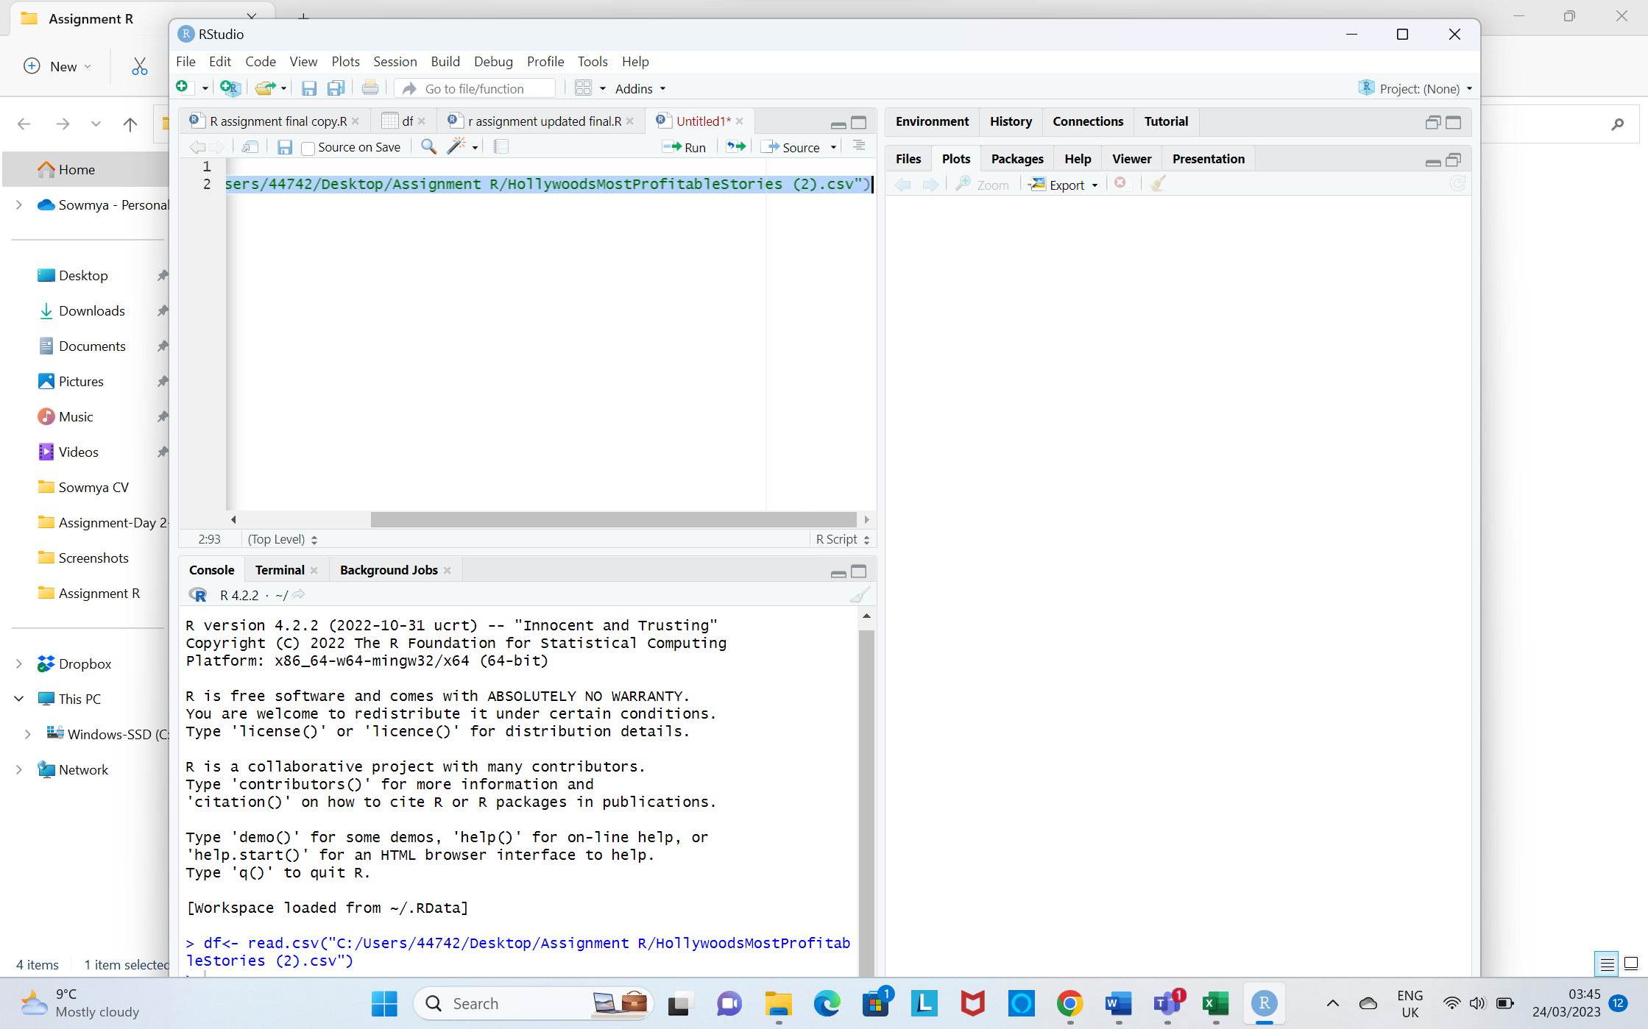

**To view the contents of the data**

Use View(df)

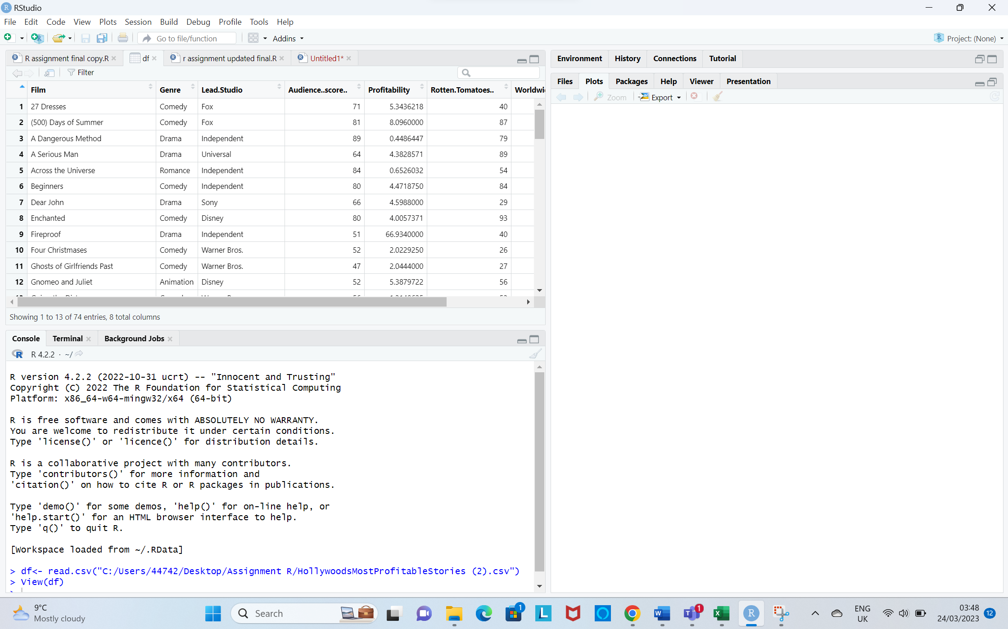

**Load the package in R**

The “install.packages” command downloads the package files, extracts them , and installs them on the local computer, making the package’s functions and data available for use in R scripts and programs

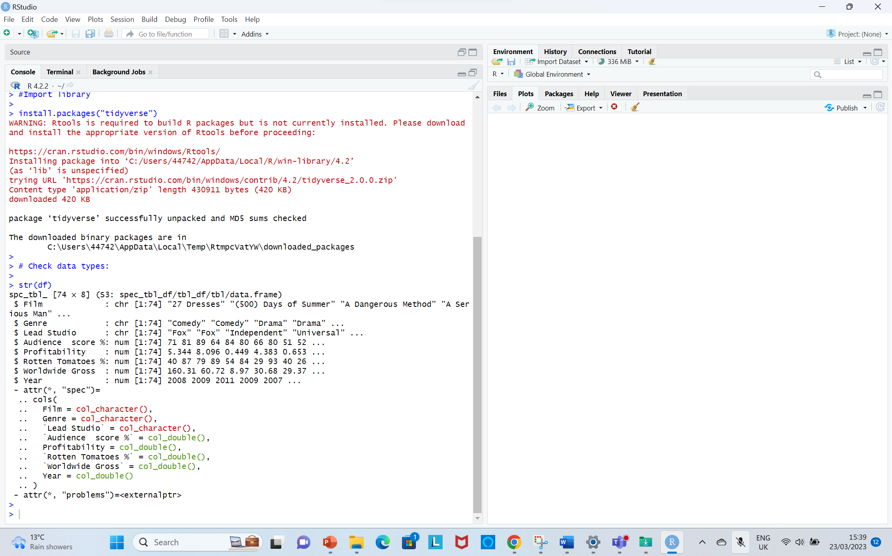

**Then check the data type of each column**

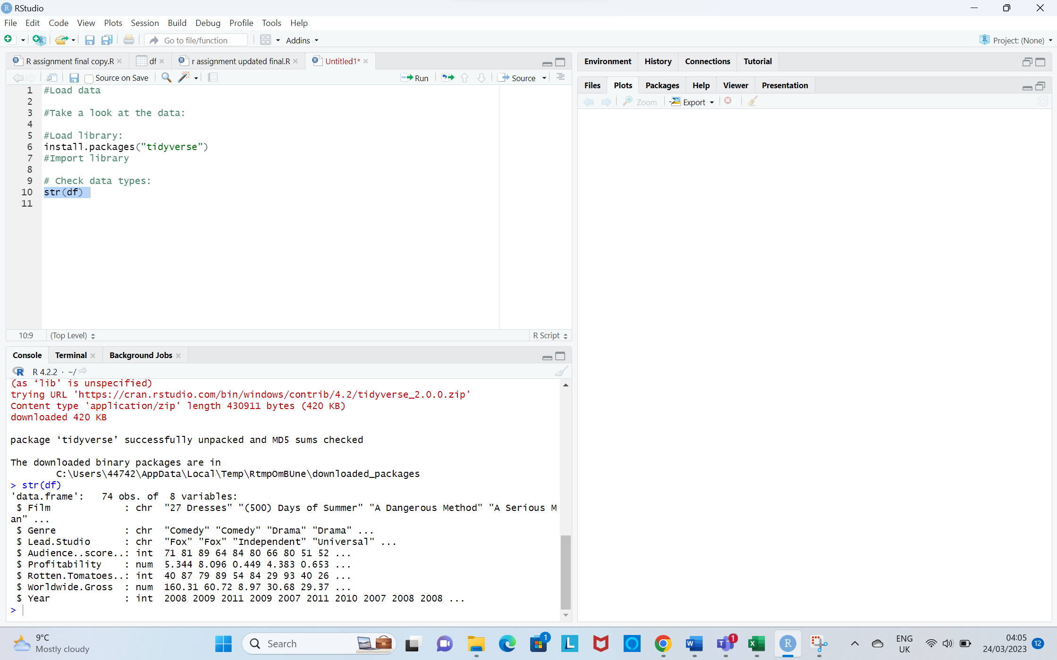

**Step 2: Process for cleaning the data**

**I.Check for missing values:**

The syntax “colSums(is.na(df))” in R computes the total number of missing or NA values for each column of a data frame df.



**II.Drop the Missing values**

The syntax “na.omit(df)” removes all rows containing missing or “NA” values from a data frame “df”.

colSums(is.na(df))​ is used to verify that rows have been removed.

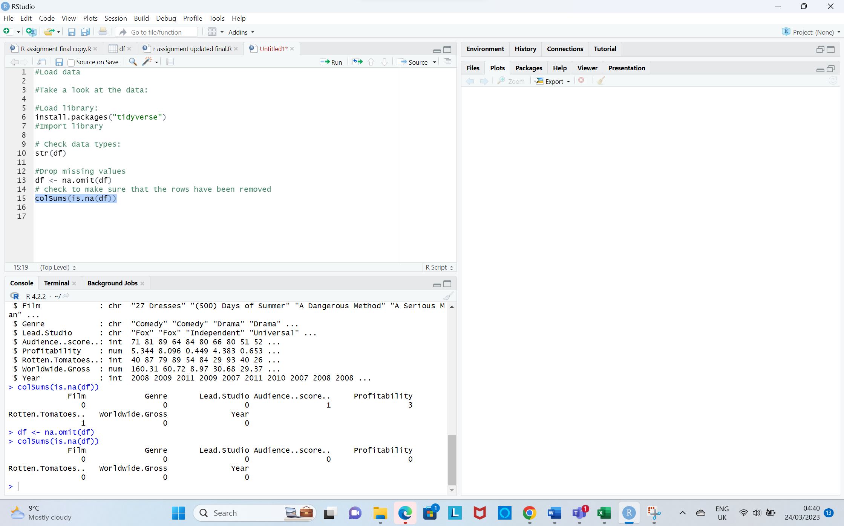

**III.Check for duplicates**

This syntax dim(df[duplicated(df$Film),])[1]  computes the number of rows in a subset of a data frame df that contain duplicated values in a specific column Film.

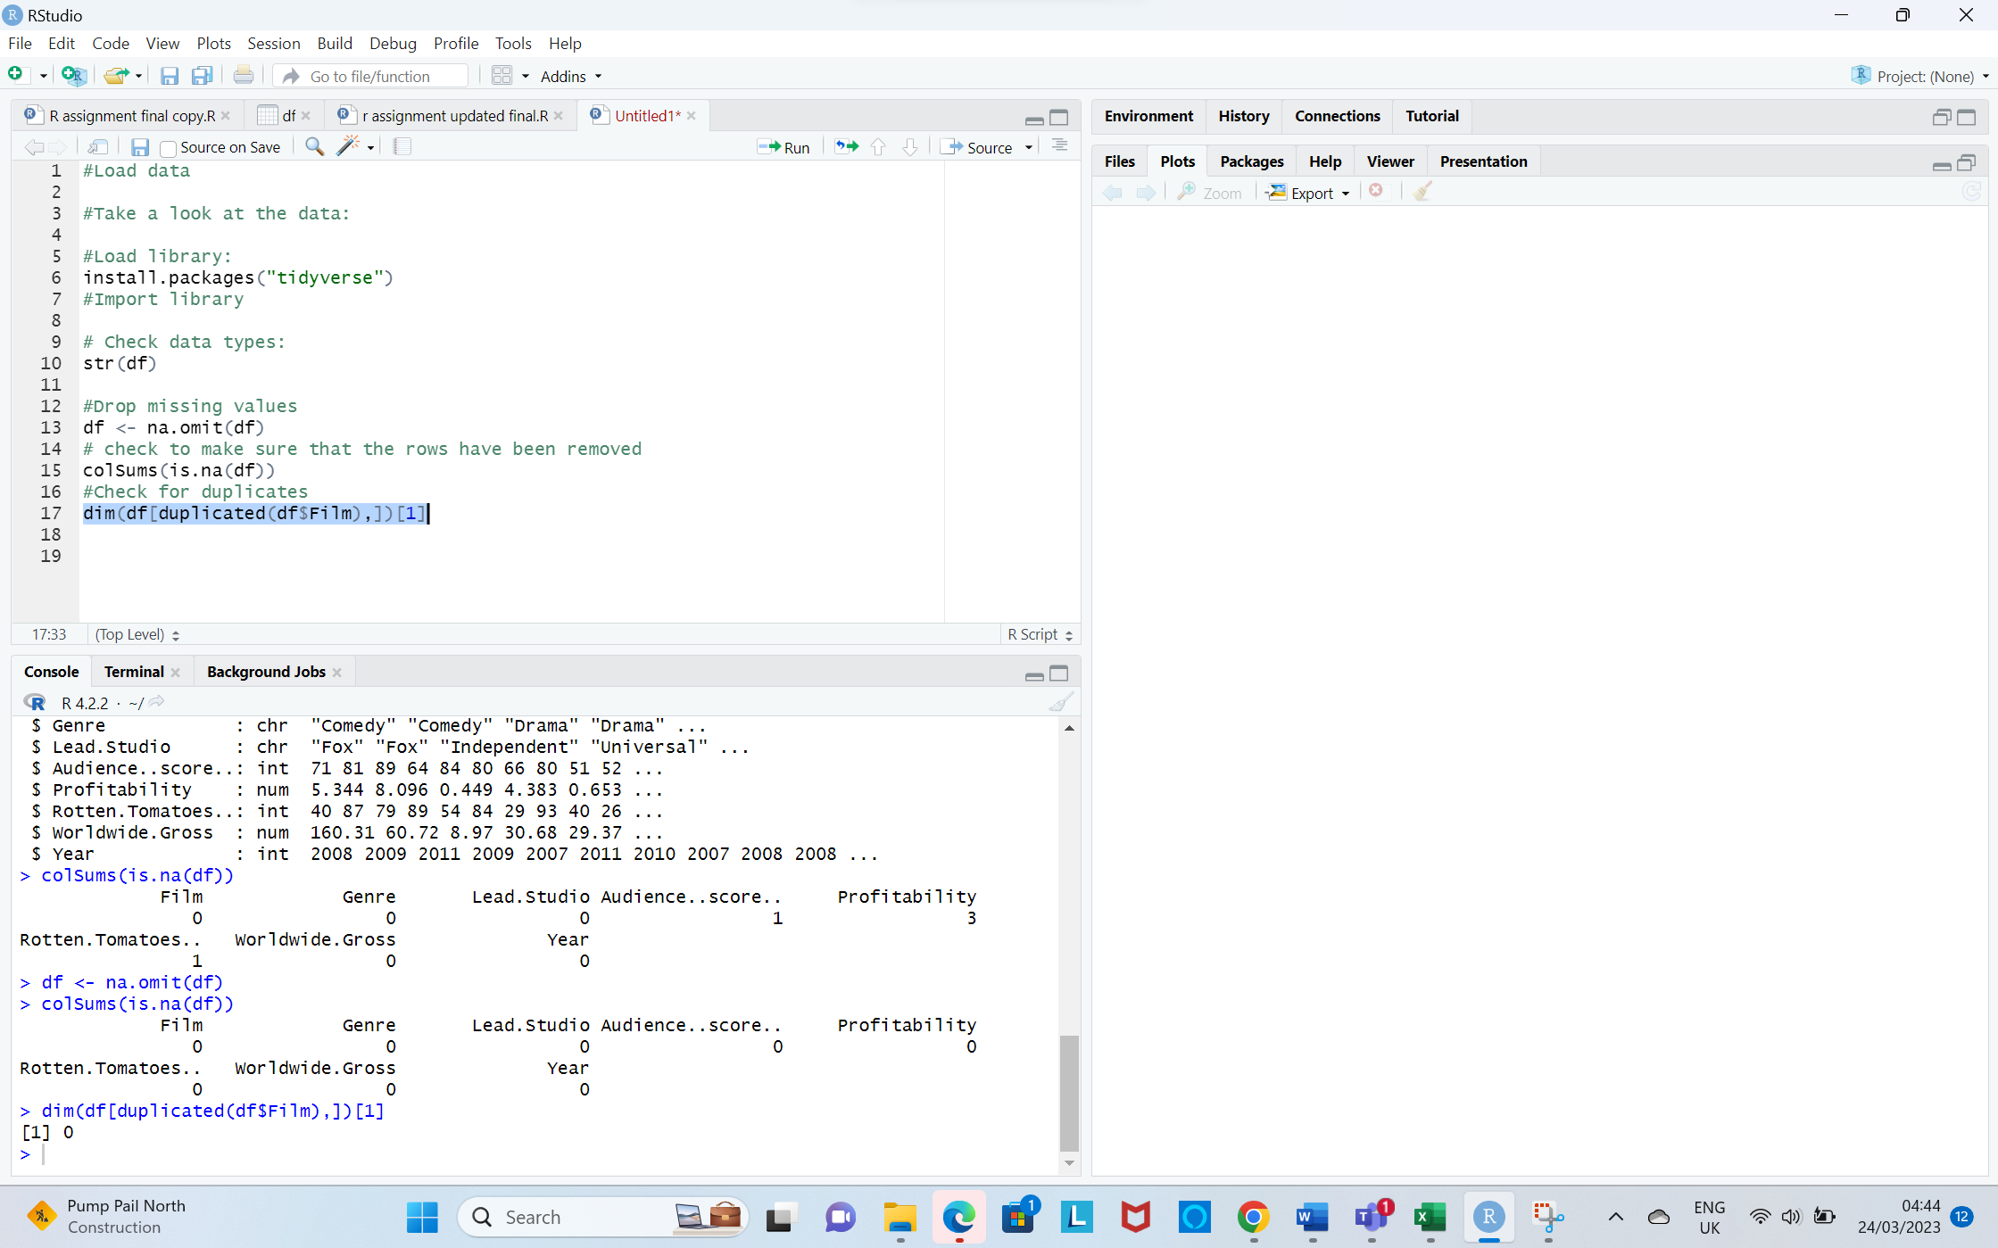

**IV. Round off Profitability column values to 2 decimal places.**

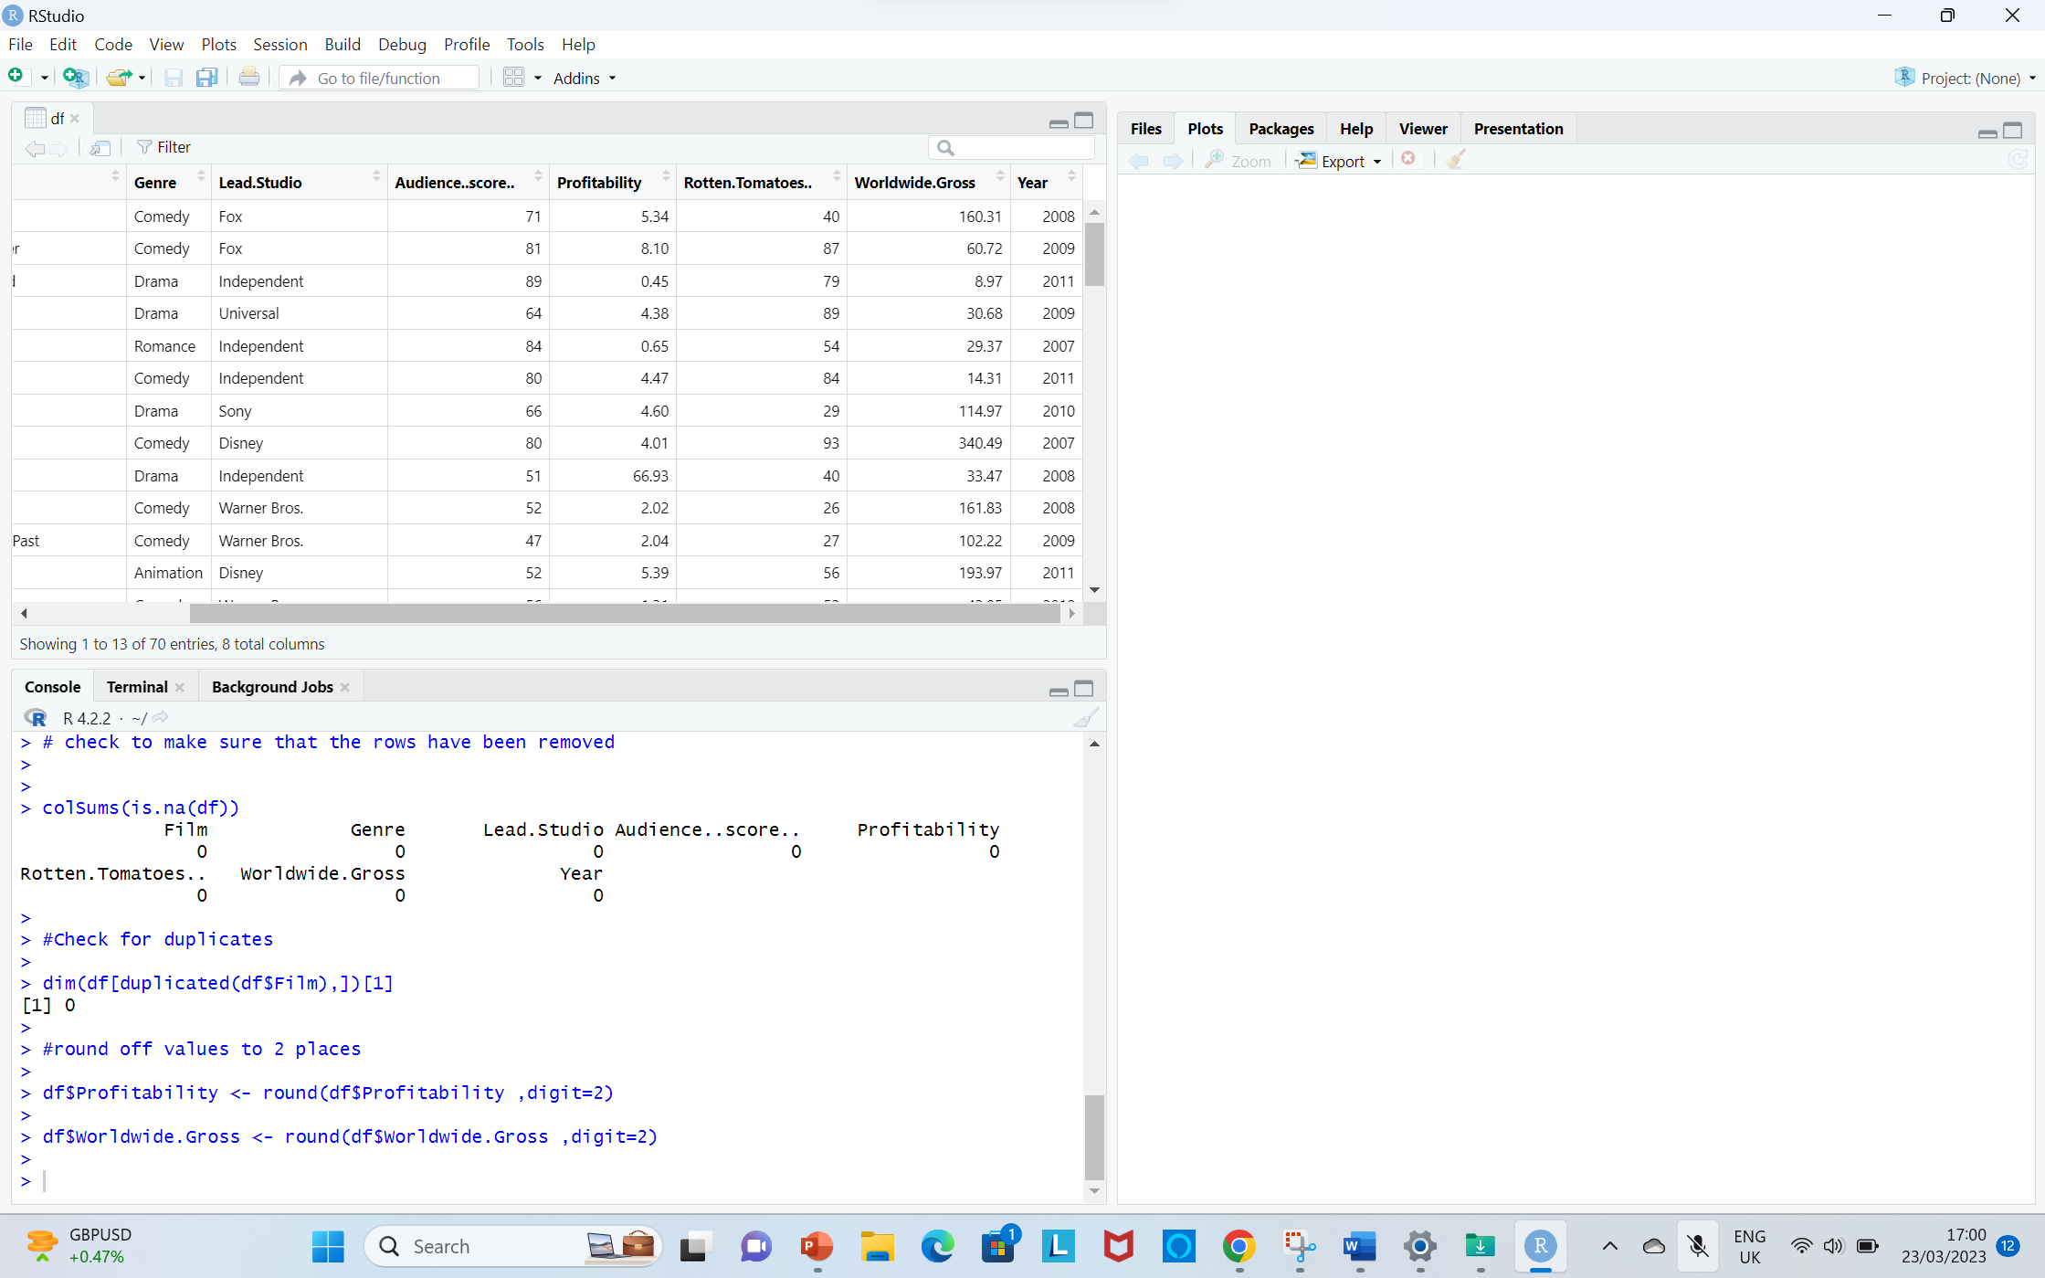

**Output**

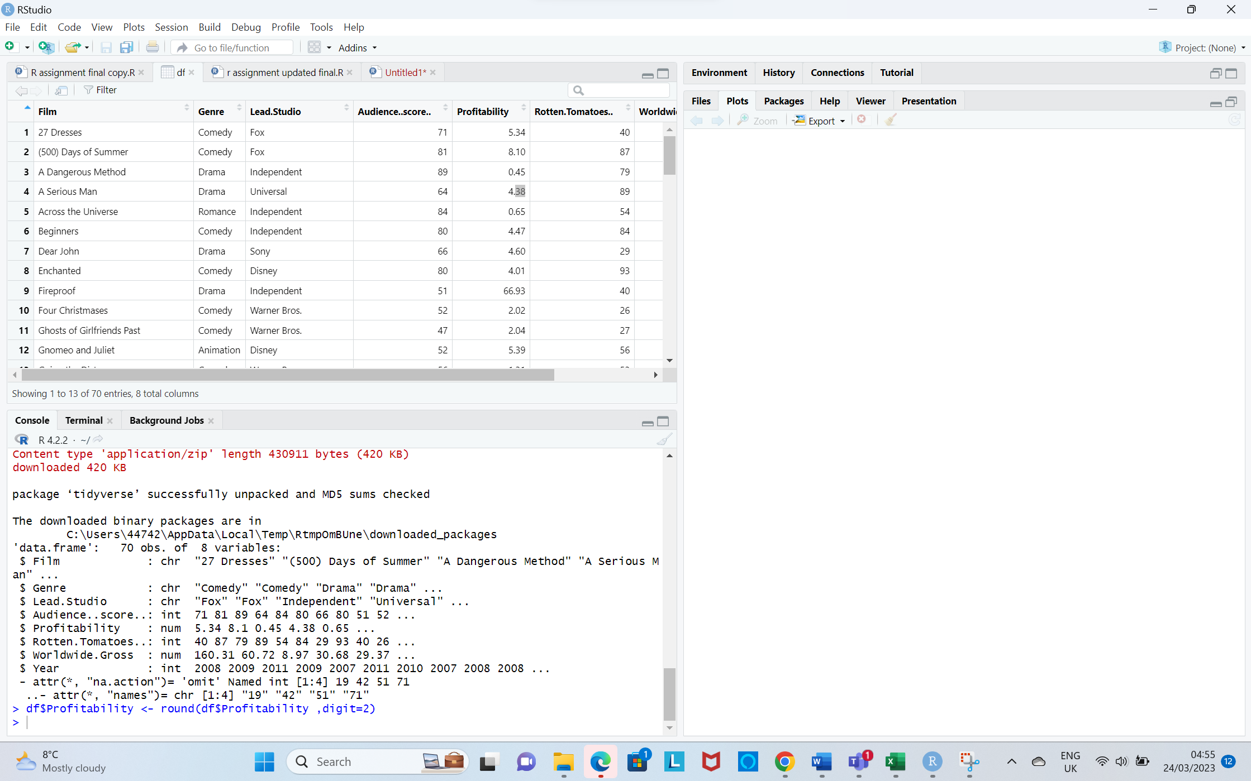

**V. Round off Worldwide Gross column values to 2 decimal places.**

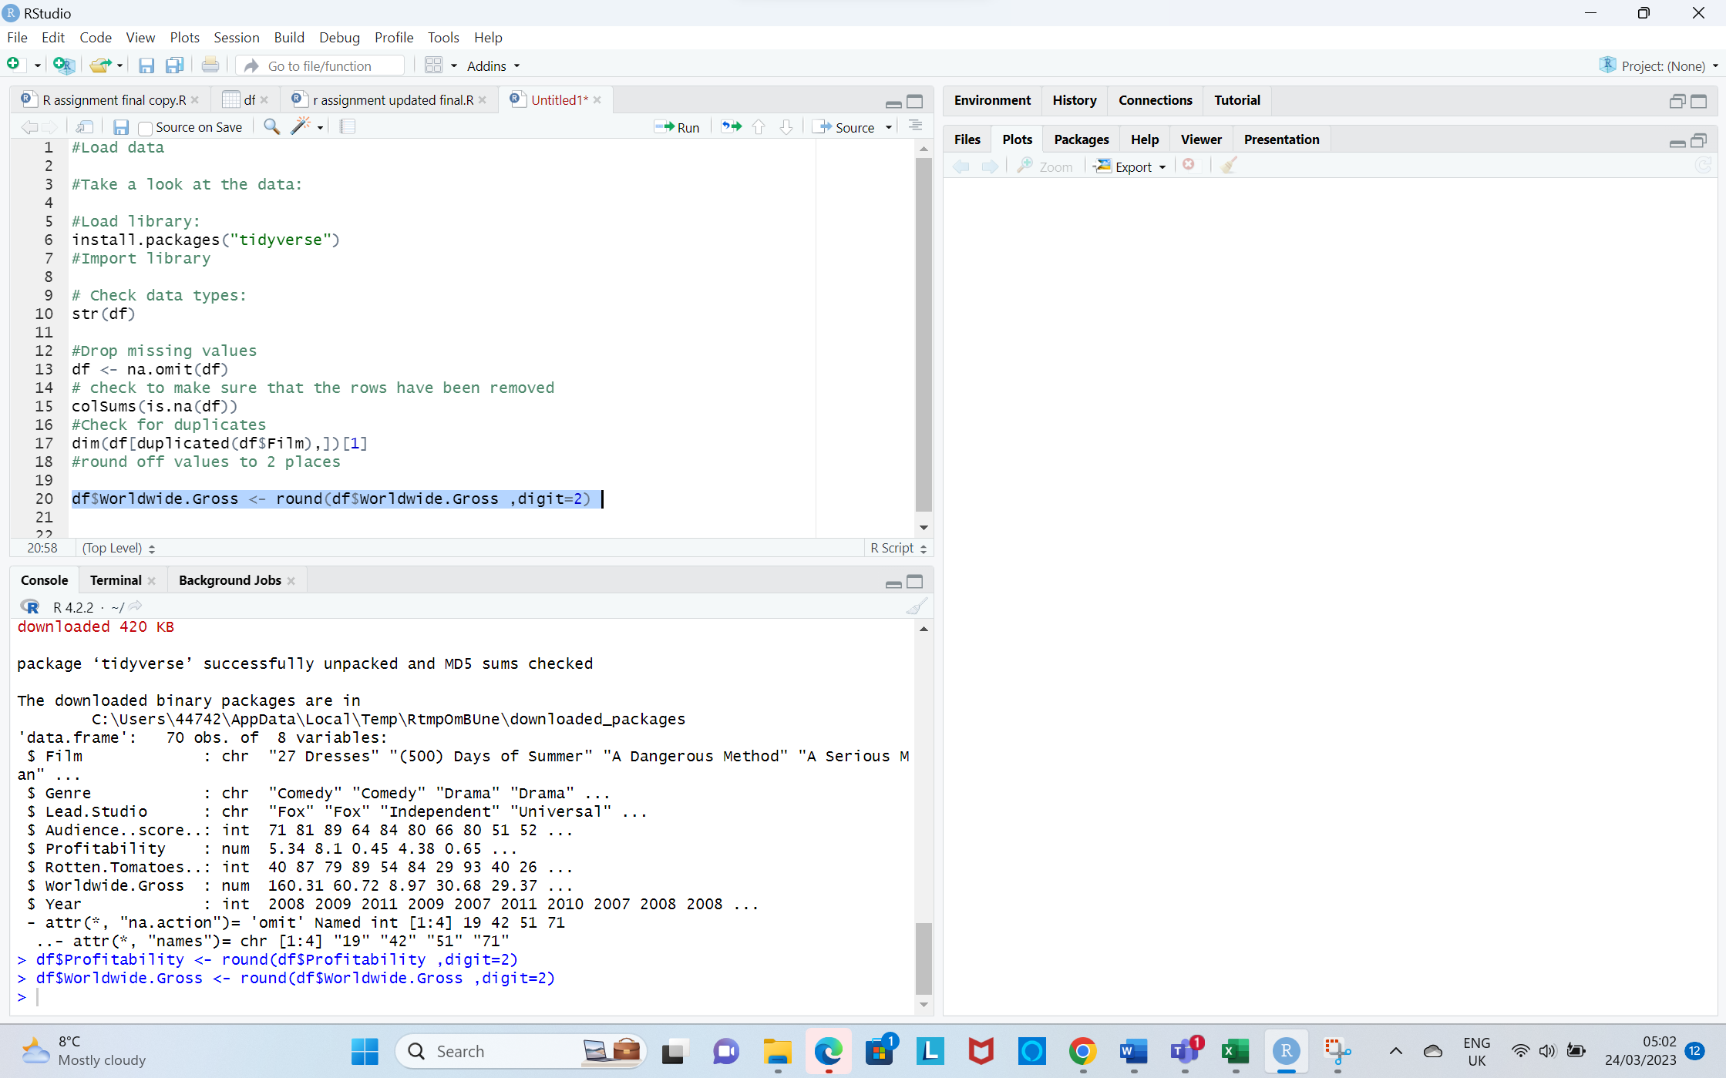

**Output**

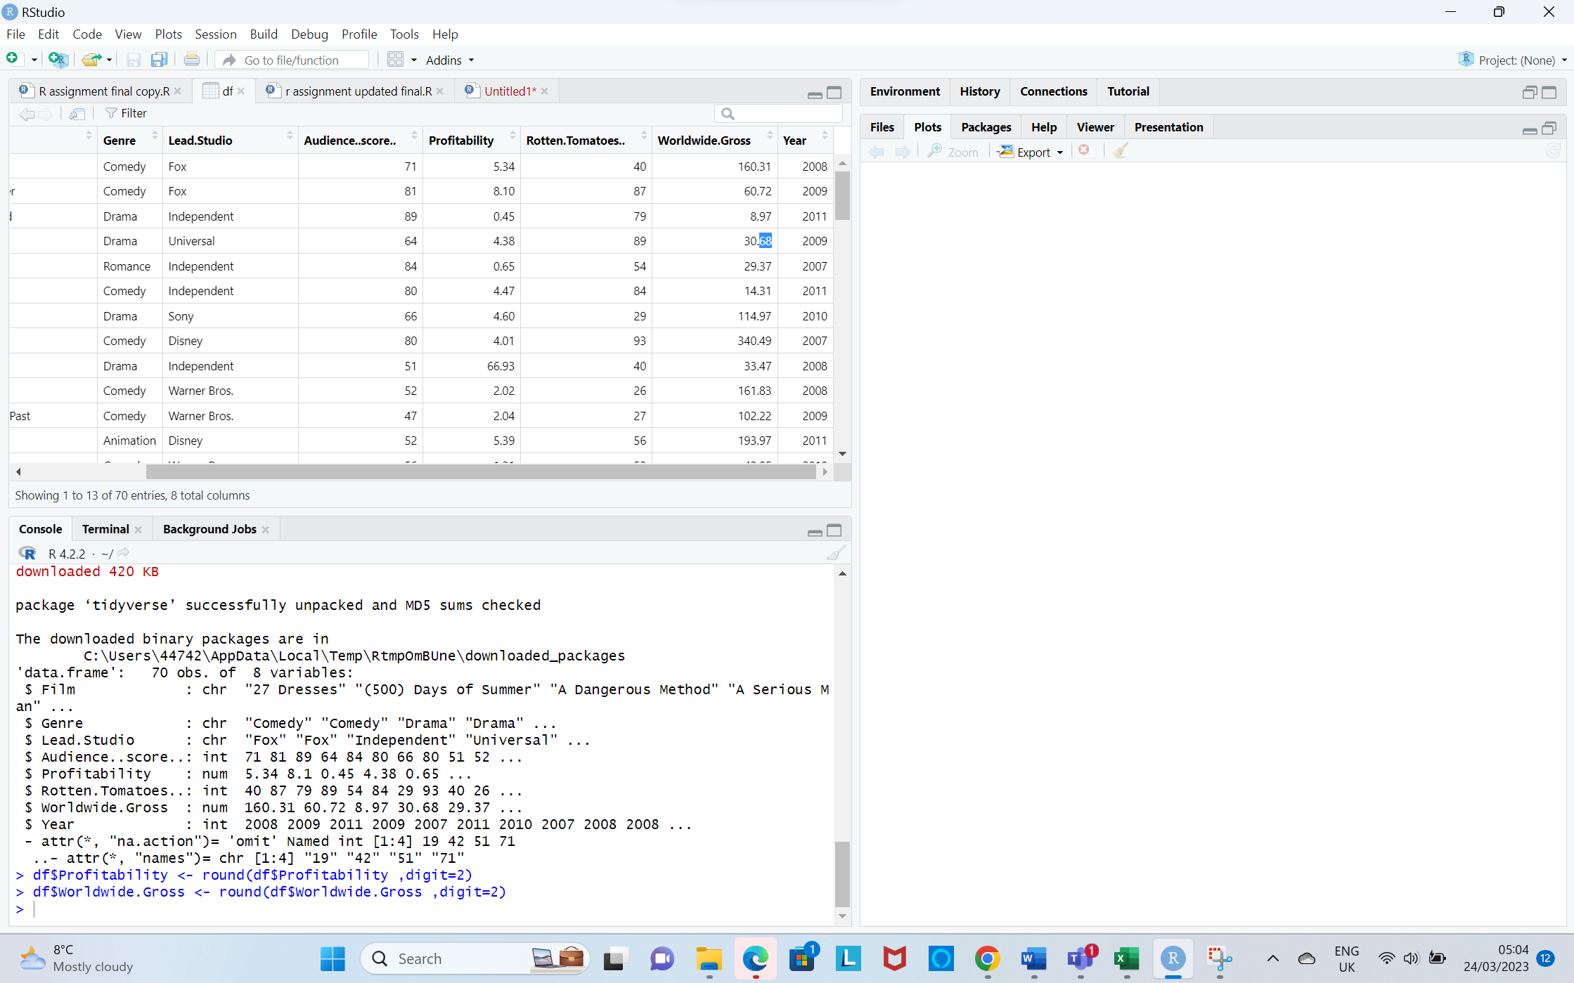

**2.1.To create a box plot**

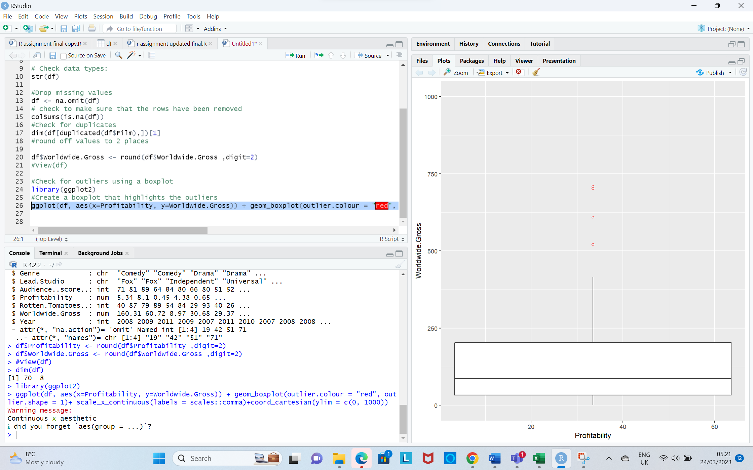

**2.2.To remove outliers in Profitability**

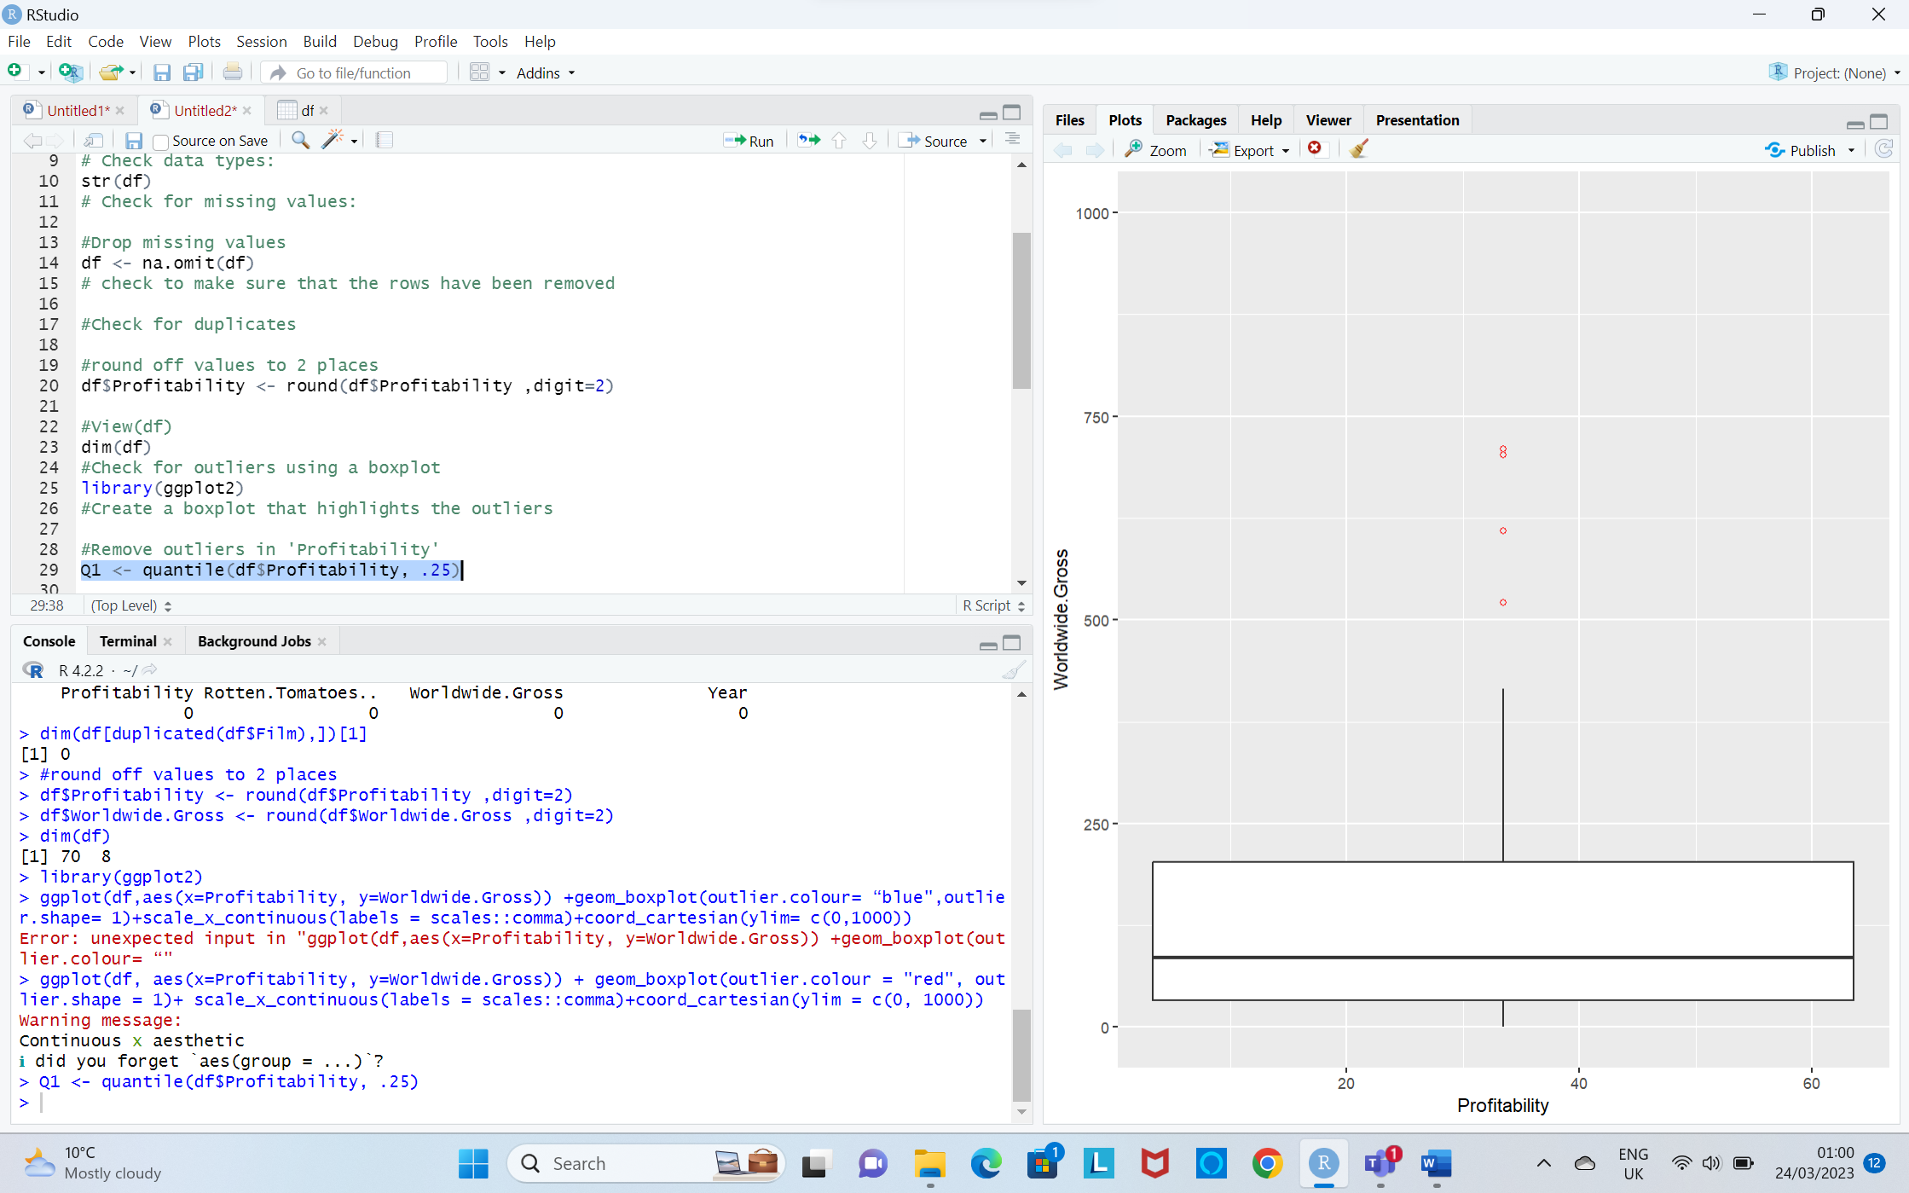

**dim(no_outliers)**

This syntax is used to extract a subset of data from a larger data frame based on a specific condition.

It easily filters out the unwanted data and focus on the information that is most relevant to the analysis.

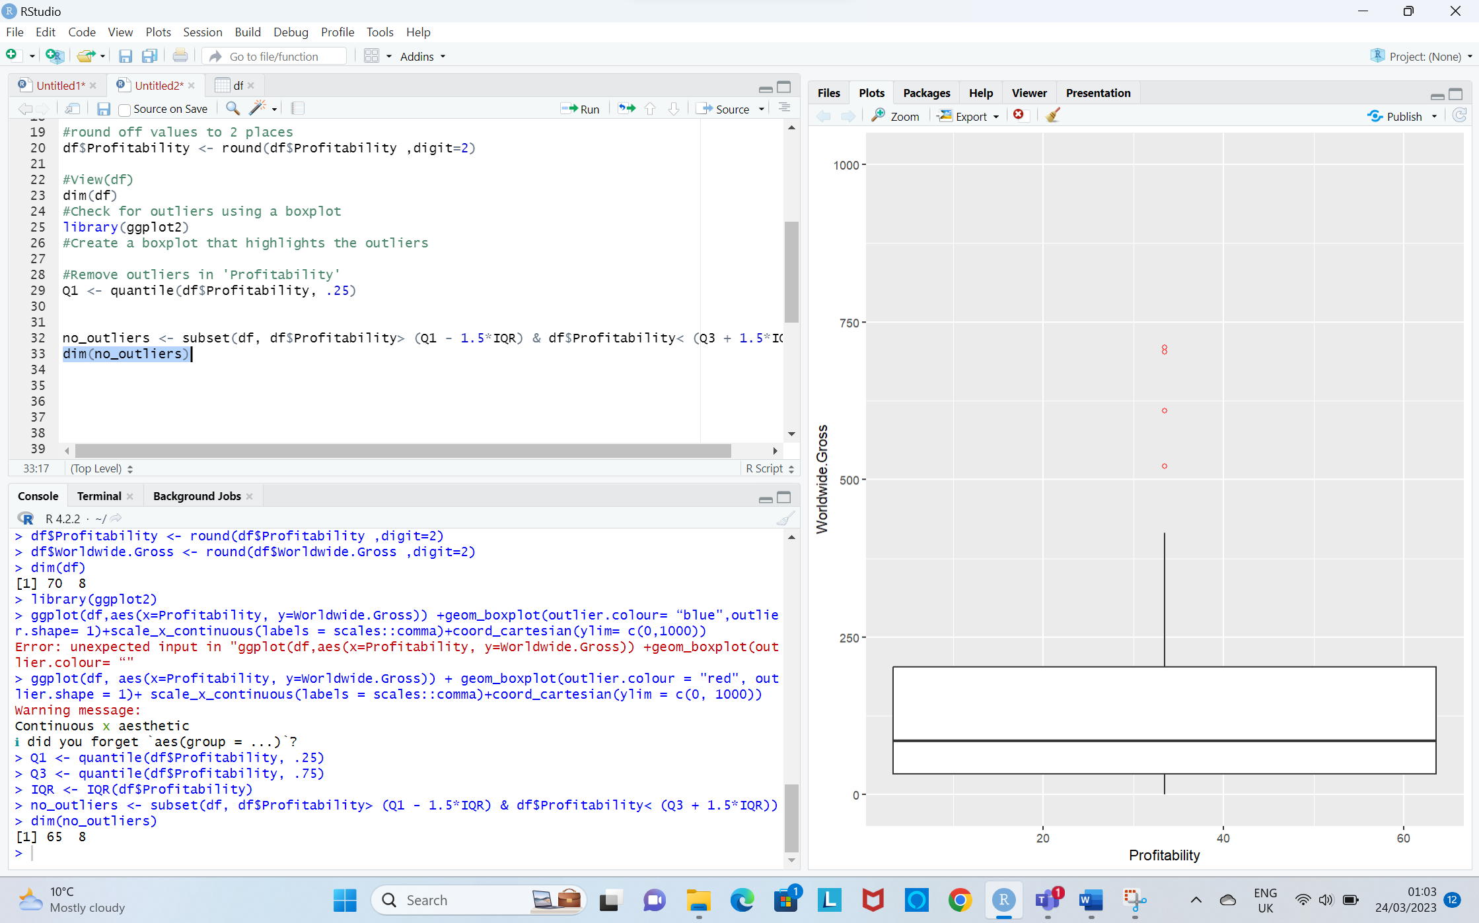

dim(no_outliers) returns a vector of two integers representing the number of rows and columns in a data frame.

**Output**



**2.3.Remove outliers in Worldwide Gross**

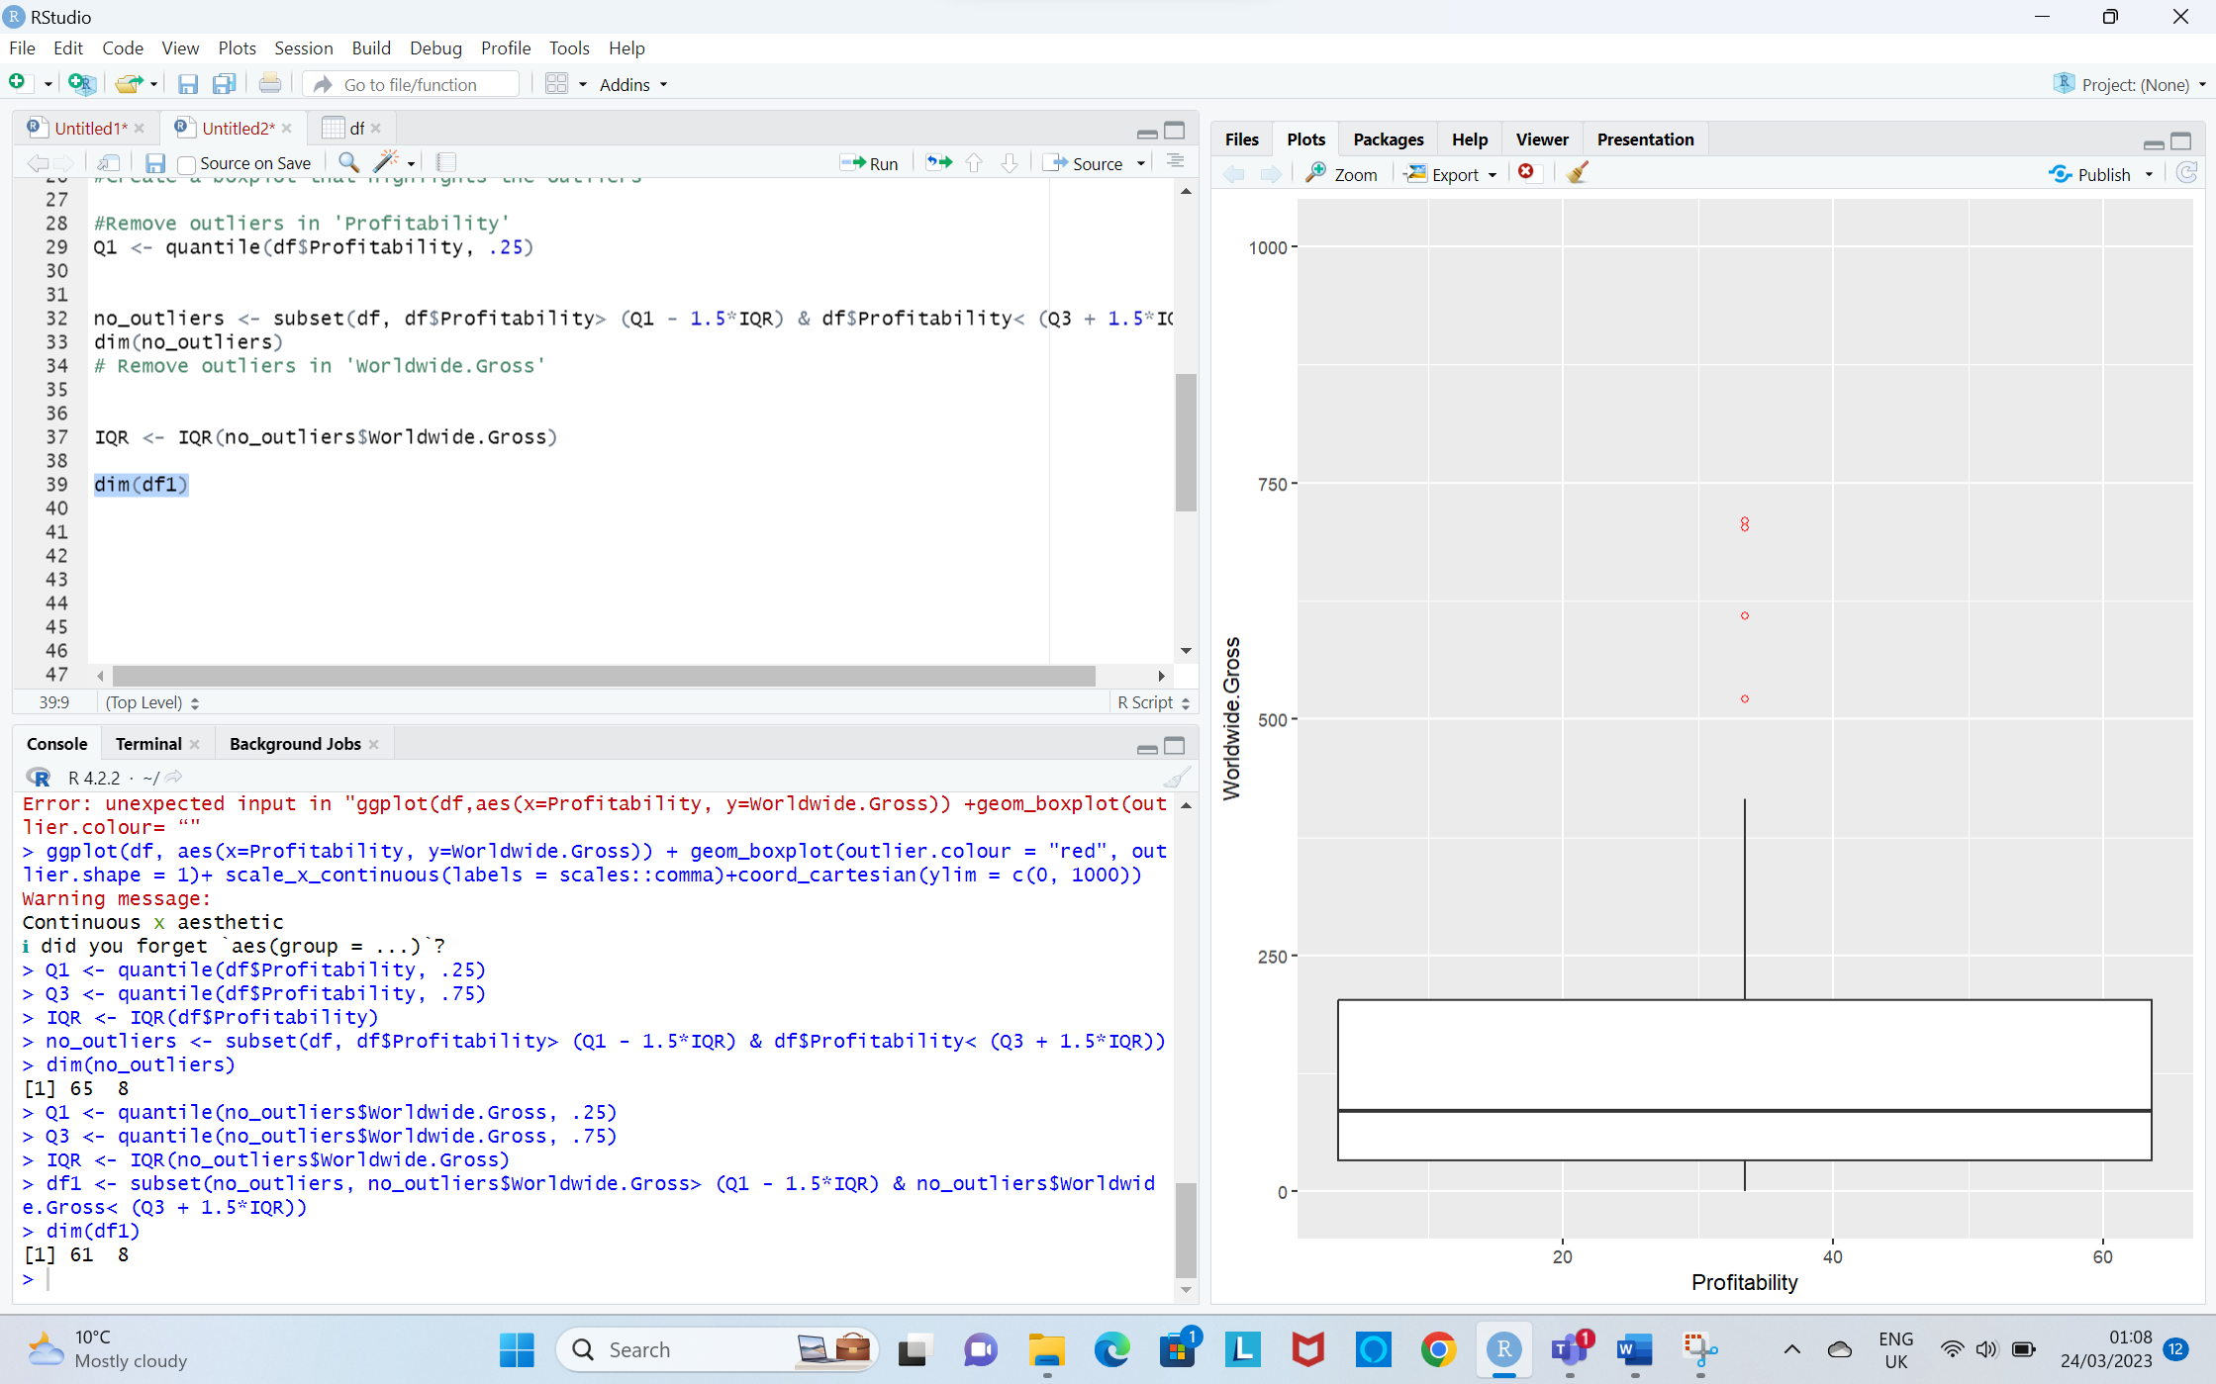

**dim(df1) output**



**Step 3**

**3.1. Exploratory Data Analysis**

Summary(df1) is used to get a summary of the distribution of values in each column of a data frame.

It is an essential function for Exploratory Data Analysis.

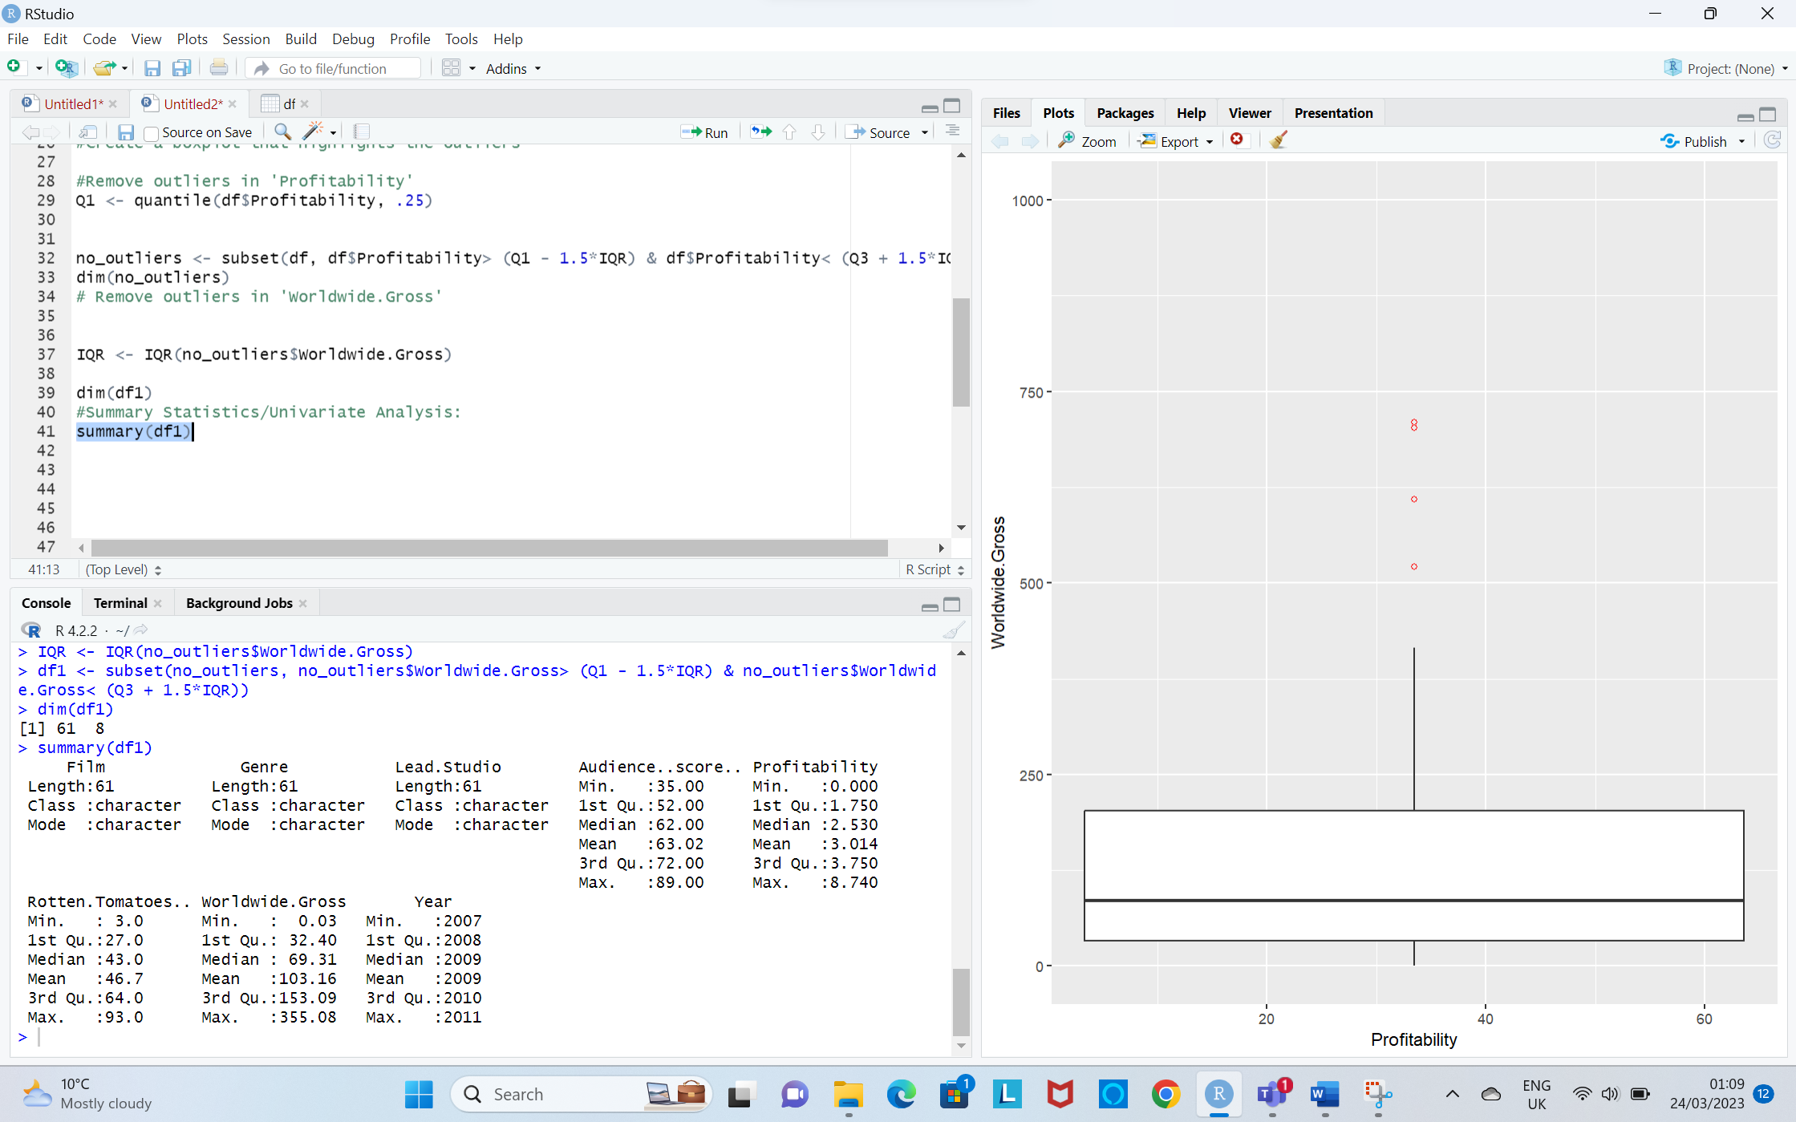

**Output**



**3.2. Bivariate Analysis**

The term bivariate analysis refers to the analysis of two variables. You can remember this because the prefix “bi” means “two.” The purpose of bivariate analysis is to understand the relationship between two variables.

**I.Scatter Plot** 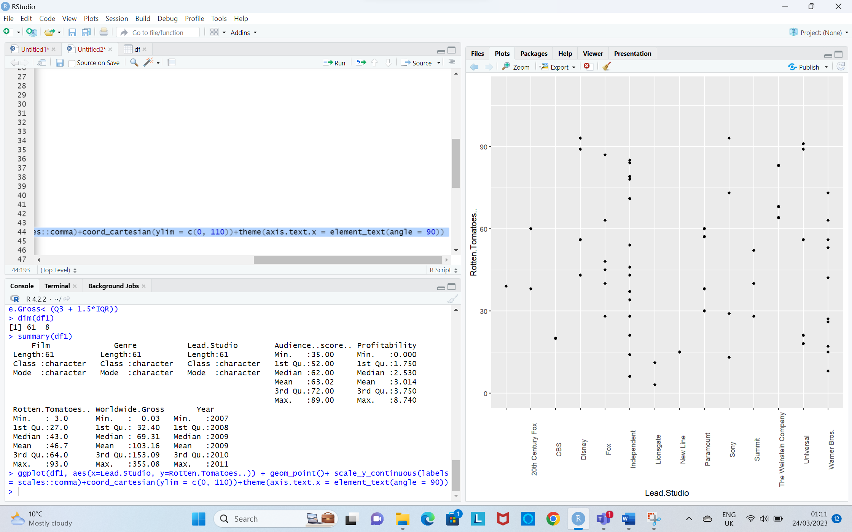

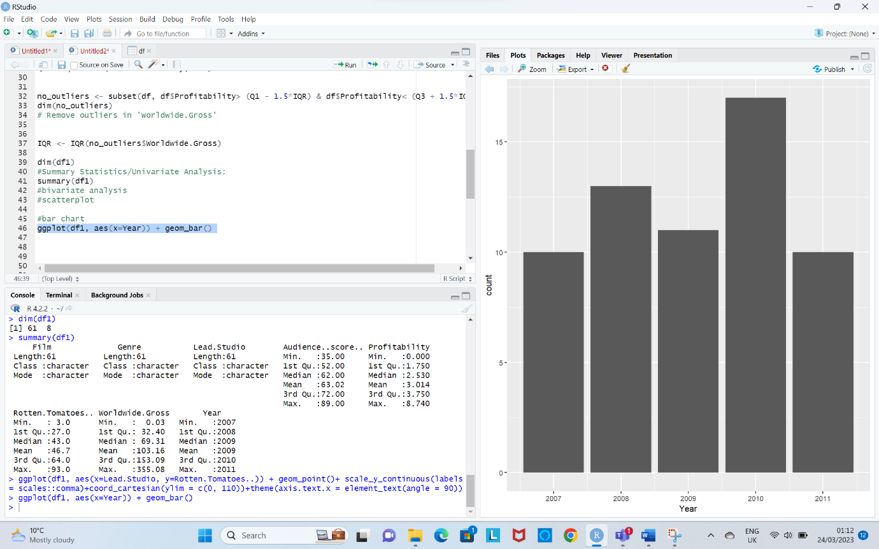**II. Bar Chart**

**4.Export data**

Export the cleaned data.

write.csv (df1, “clean_df.csv")

It writes the contents of the data frame to a file named “clean_df.csv in the current working directory, using commas to separate the values in each row.

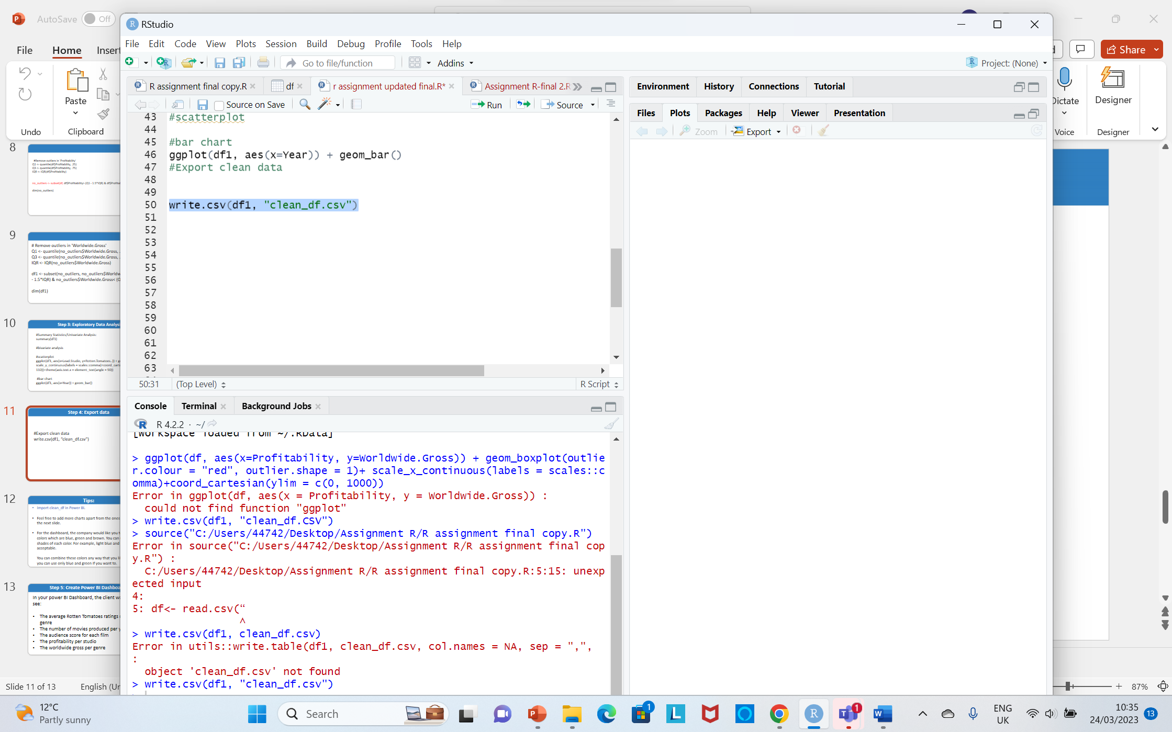

To import cleaned Csv file to Power Bi

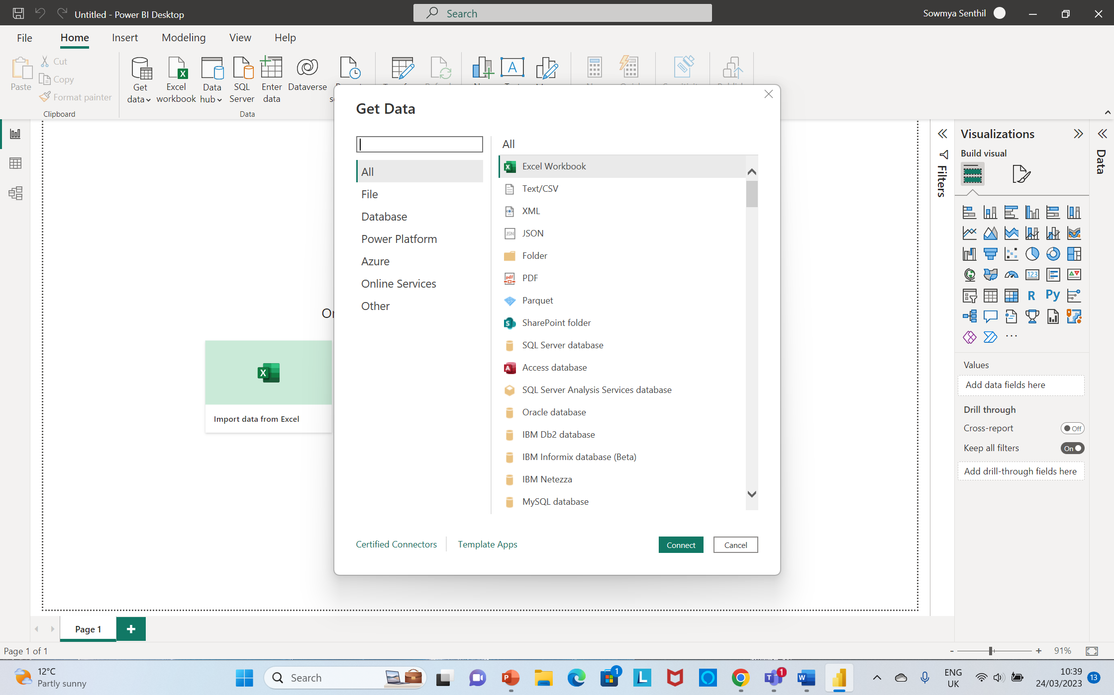

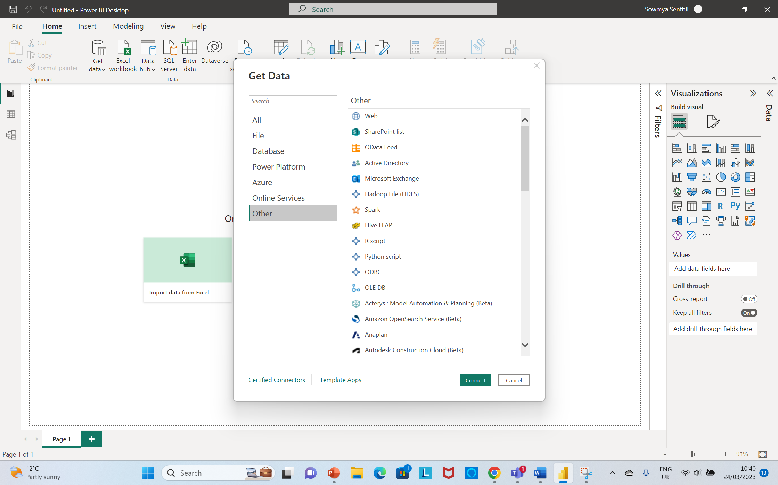

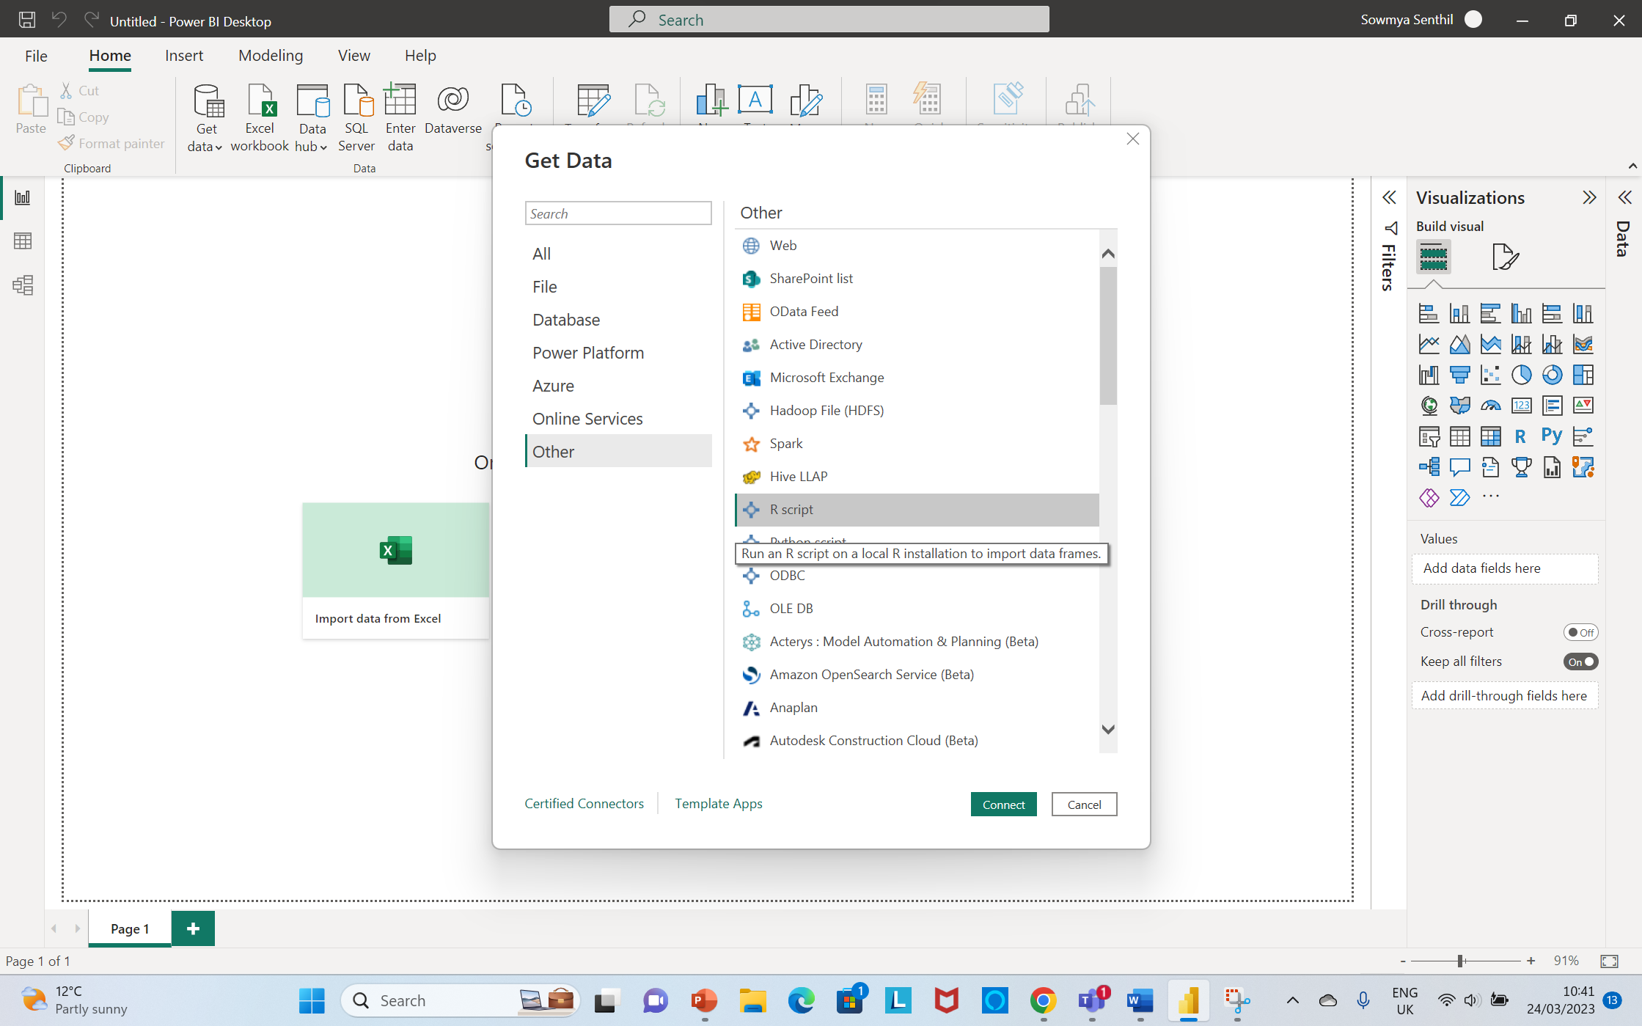

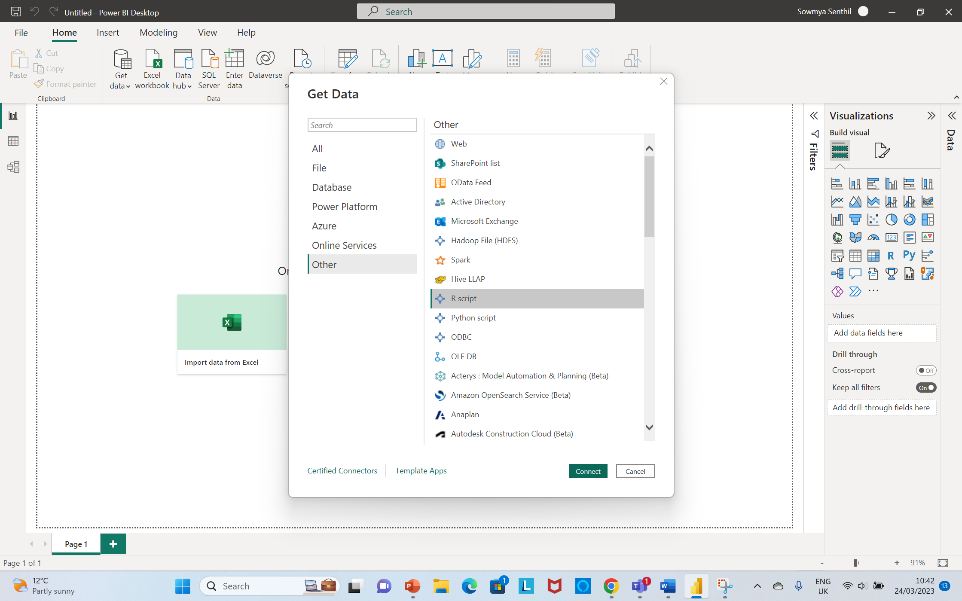

I have chosen only blue, green and brown in my charts as per the requirements.

This data set is limited to few charts only especially bar charts are more suitable.

**Power Bi Dashboard**

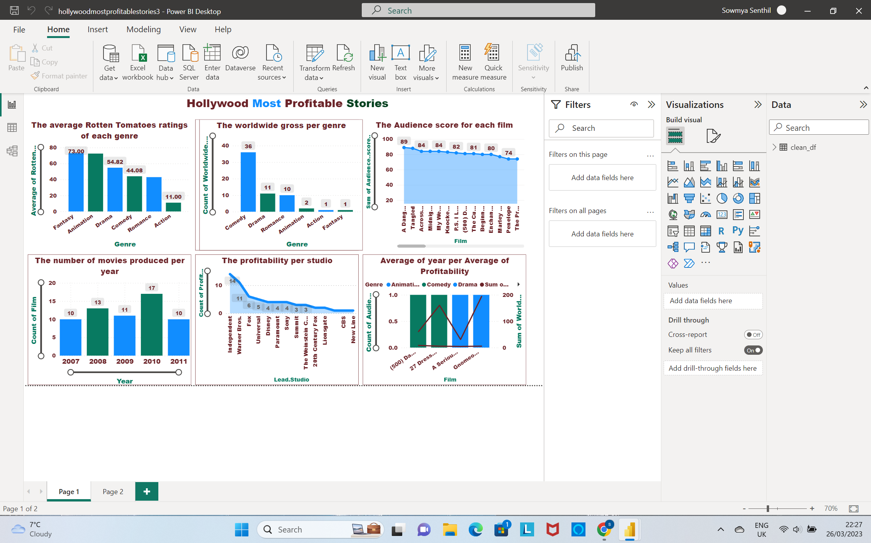

**1.Stacked Column Chart**

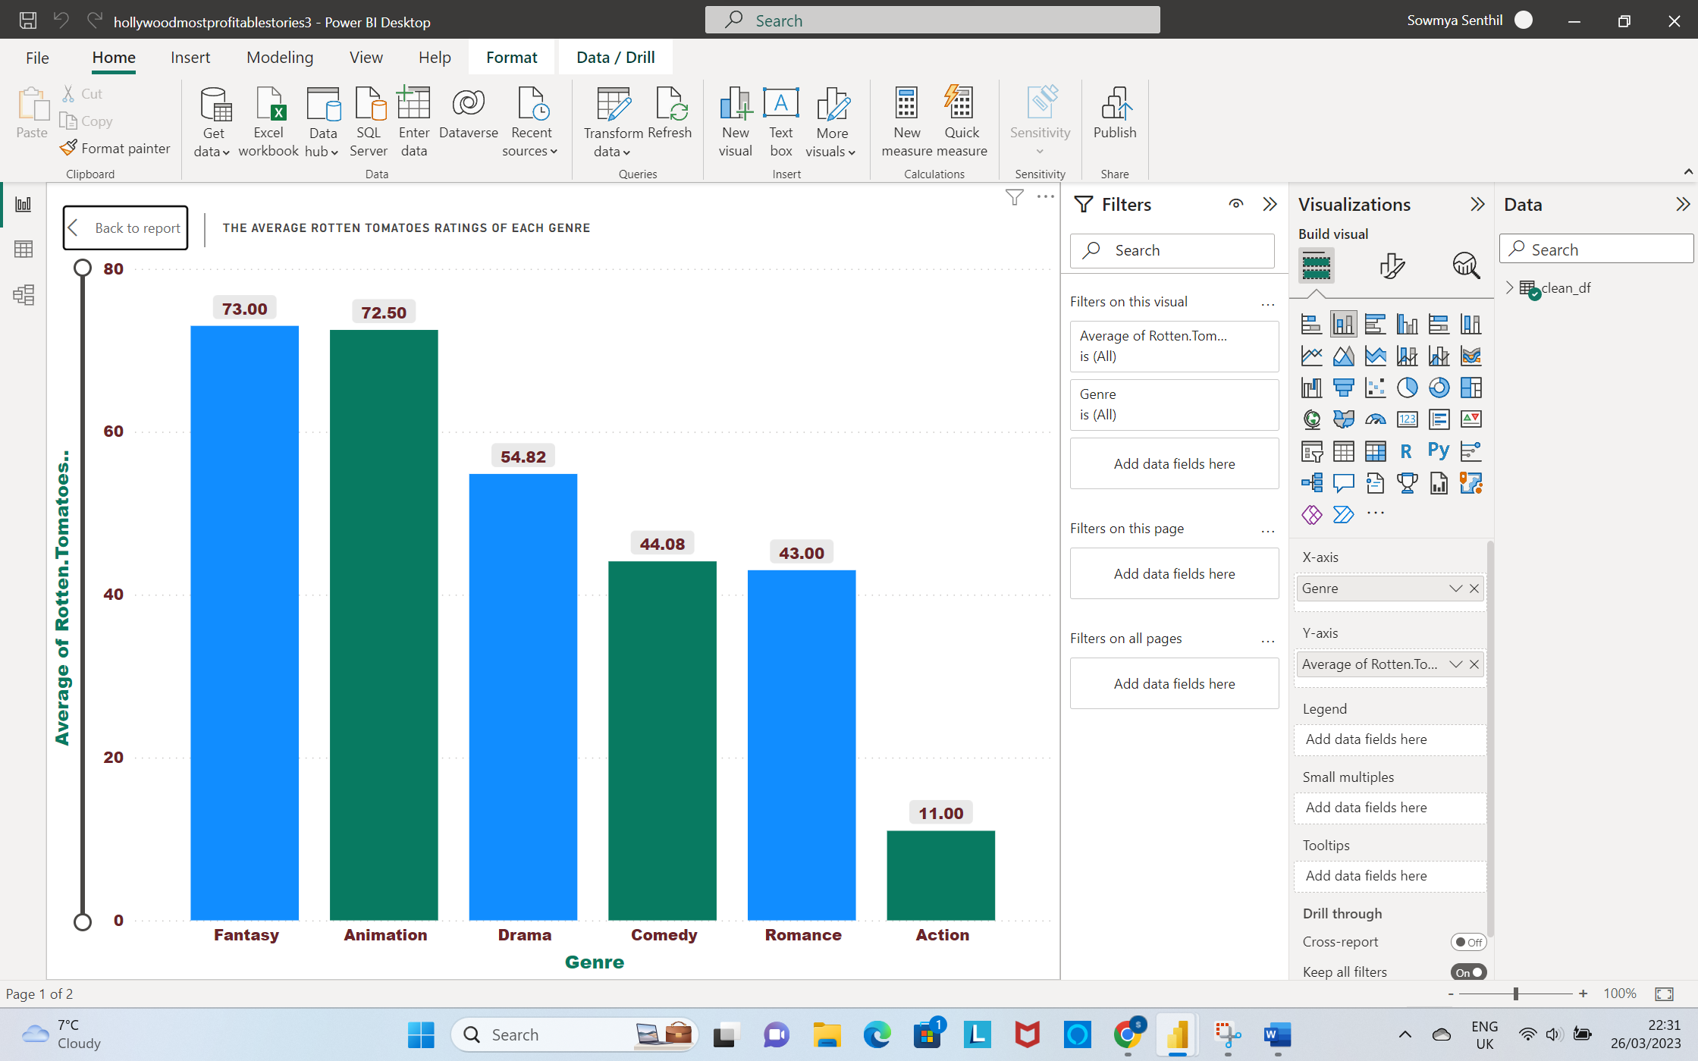

**2. Clustered Column Chart**

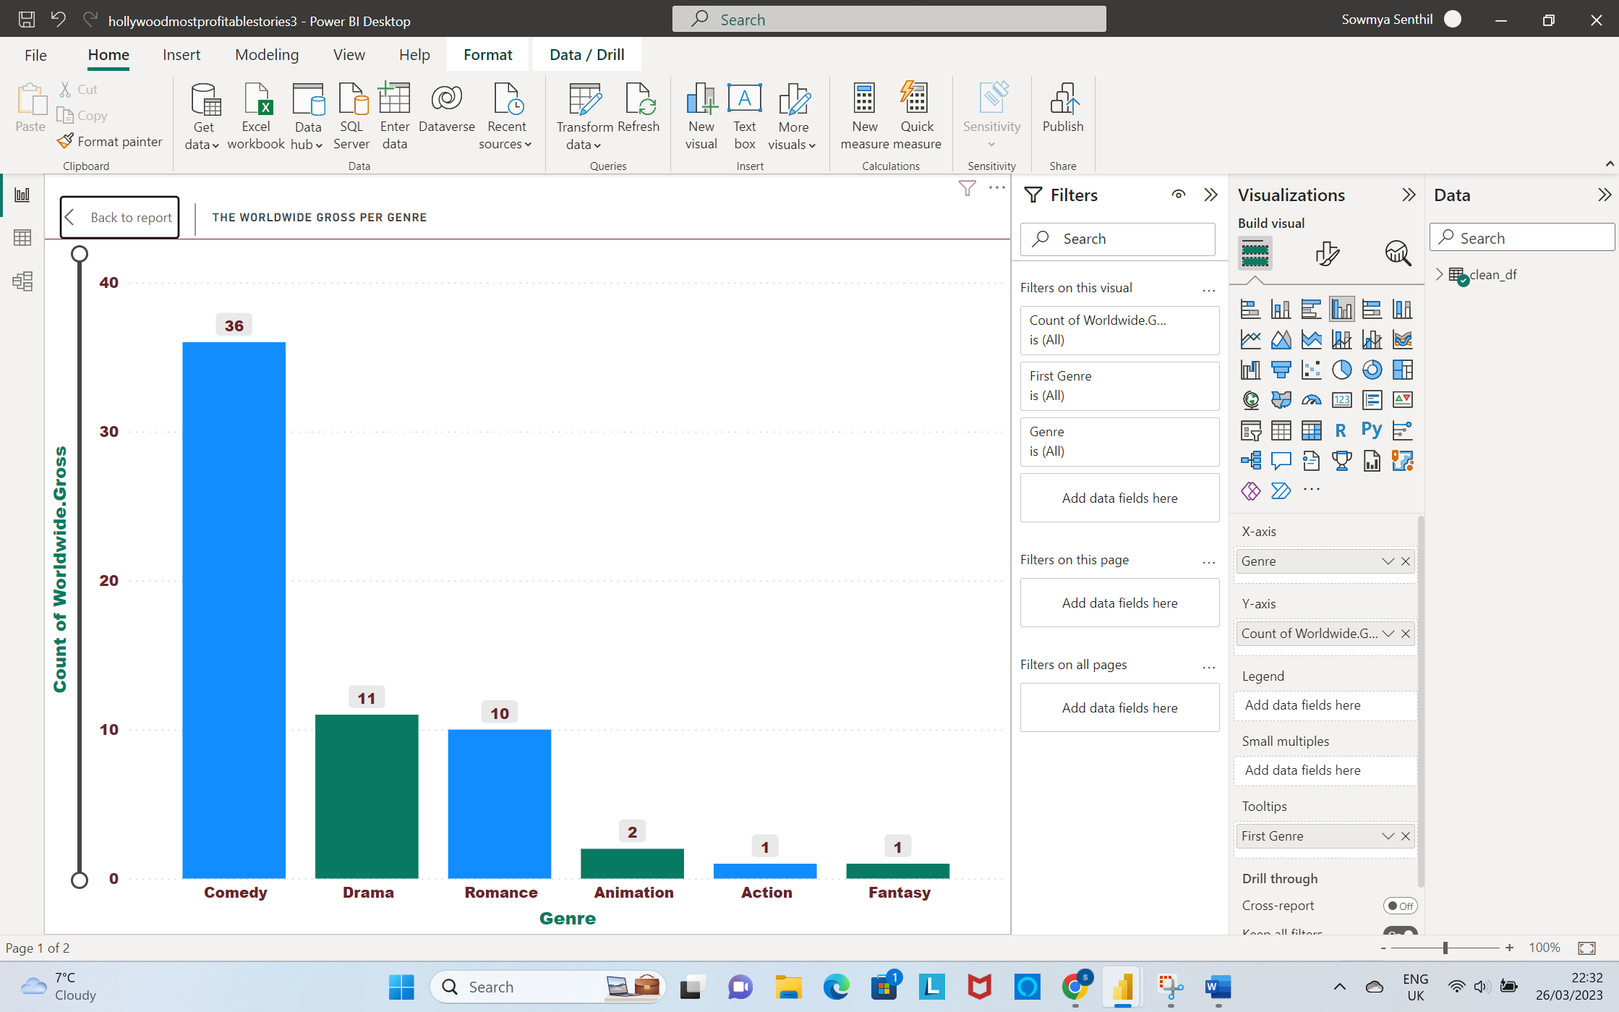

**3.Stacked Area Chart**

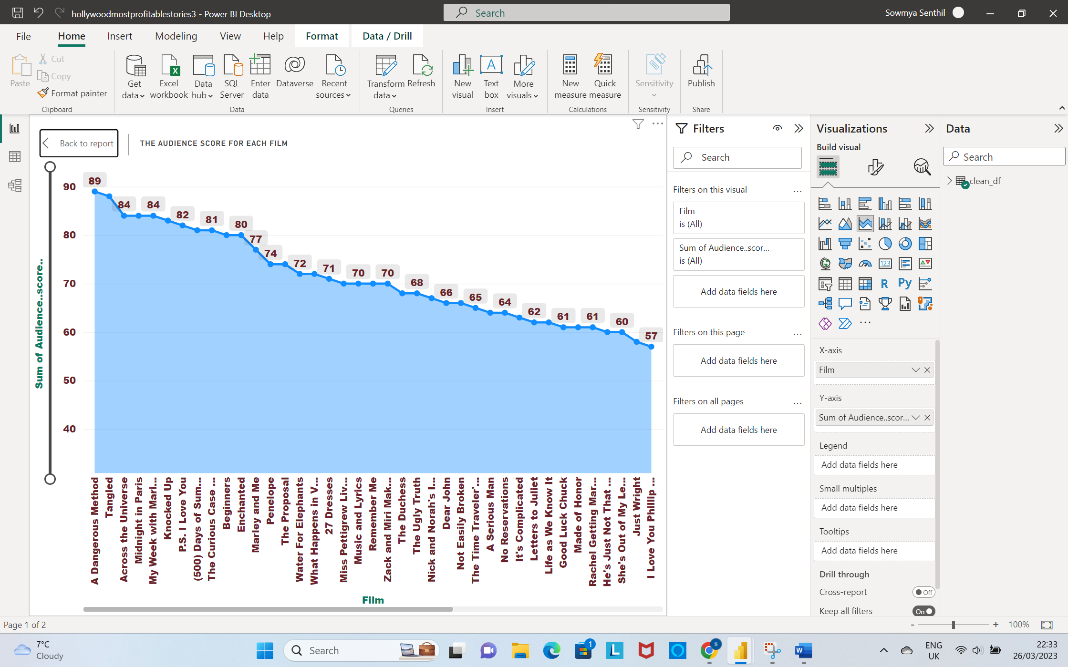

**4.Stacked Column Chart**

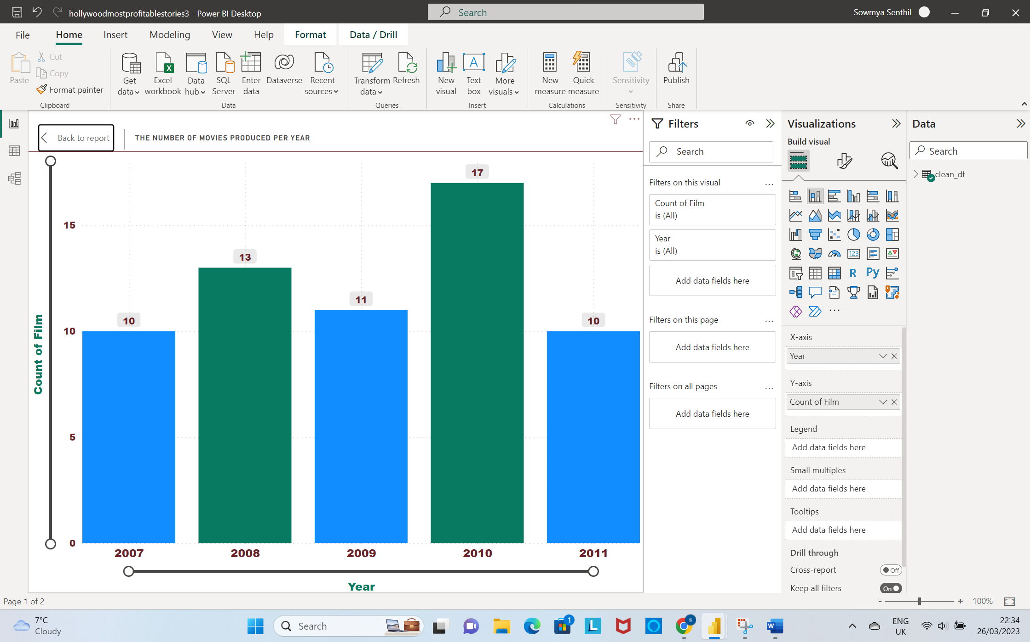

**5.Stacked Area Chart**

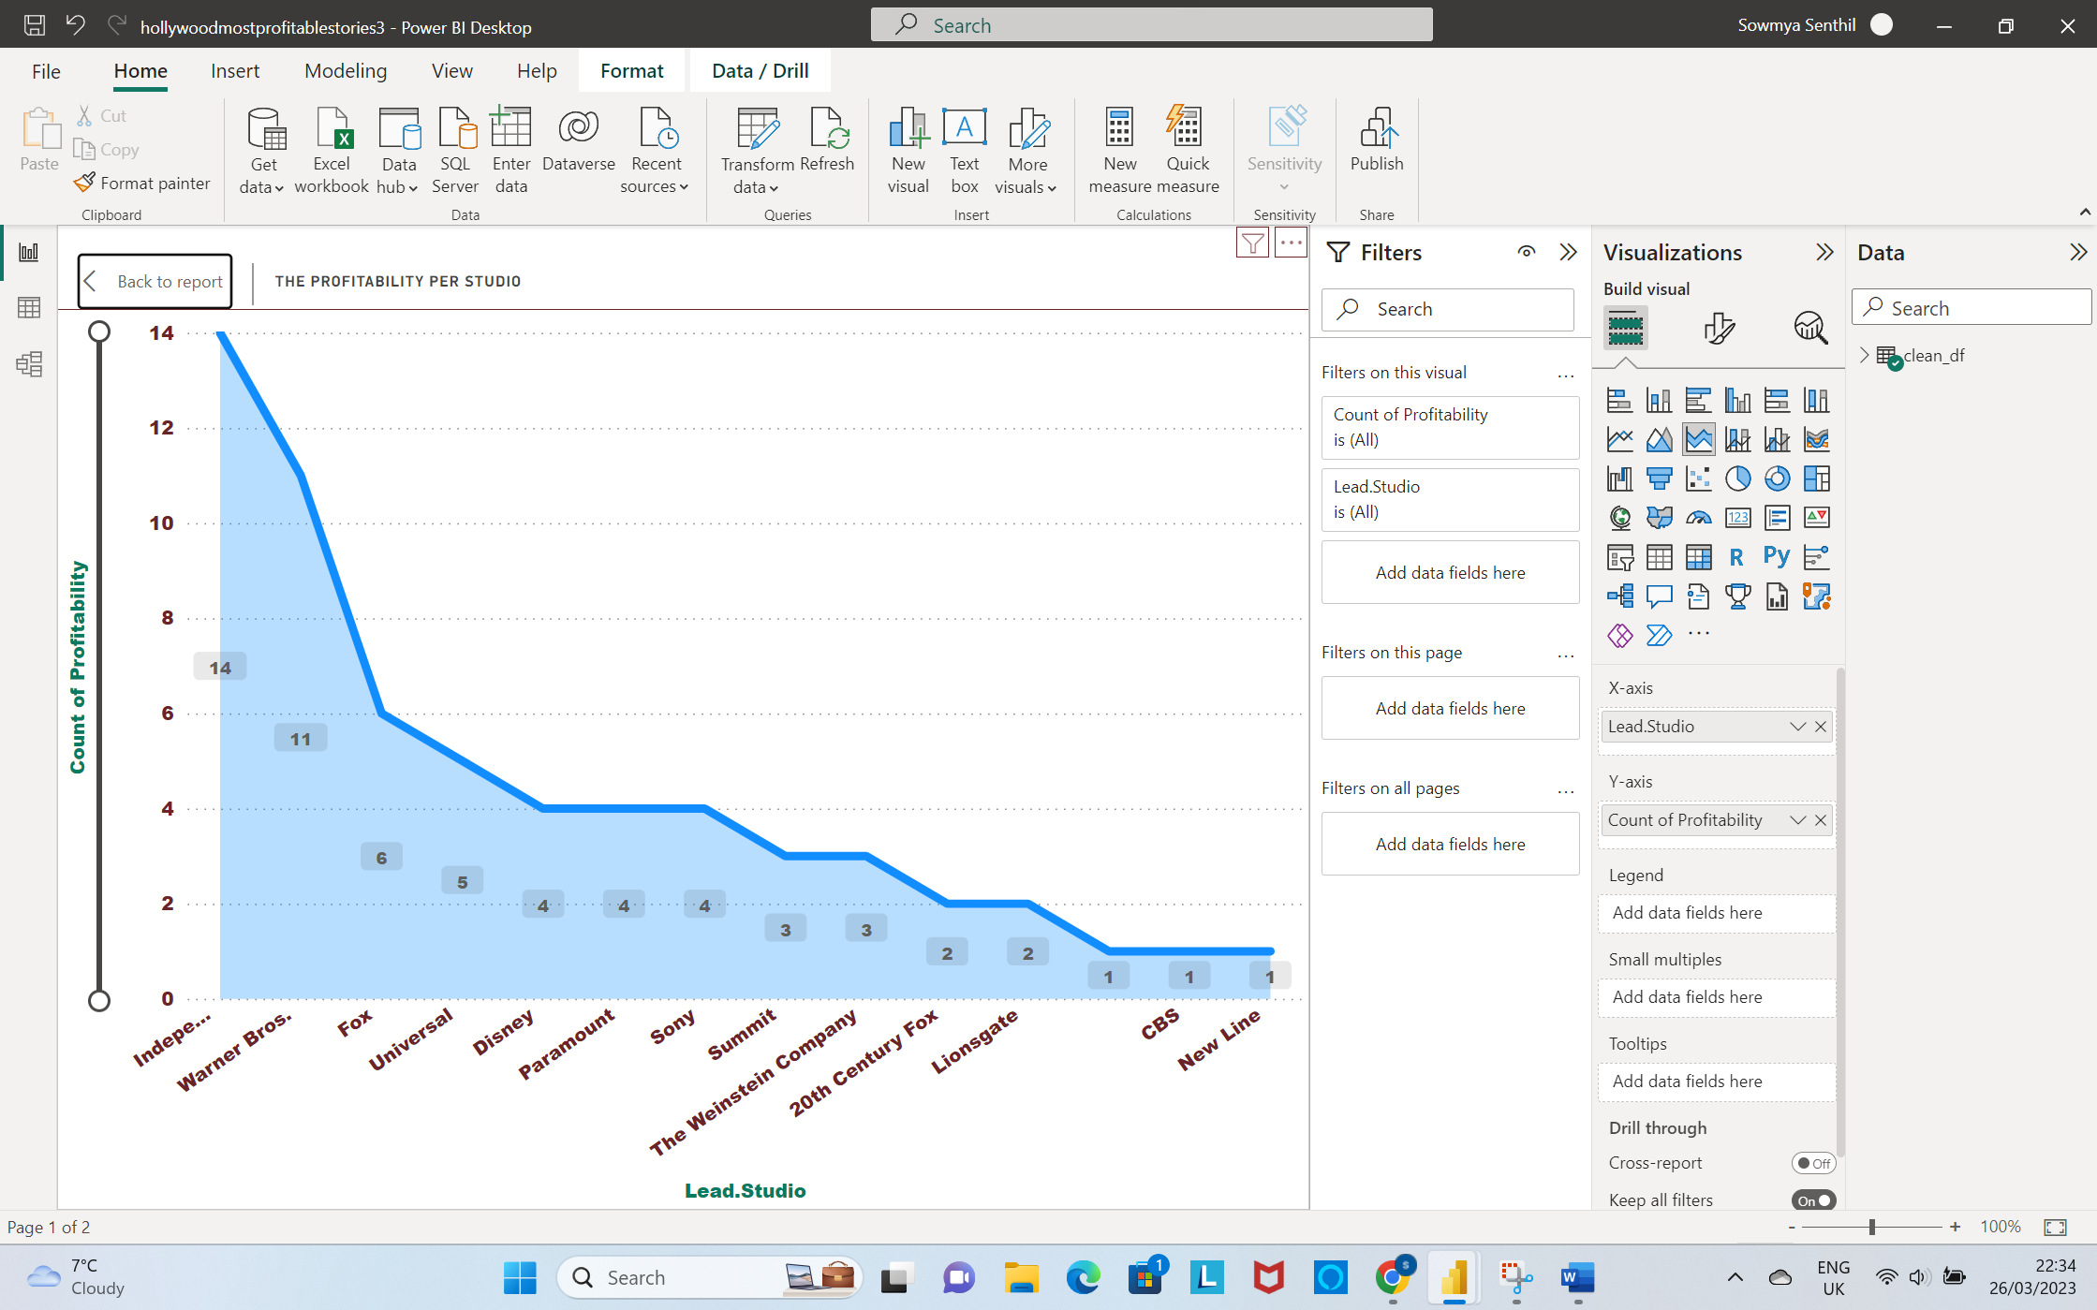

**6.Line and Stacked Column Chart**

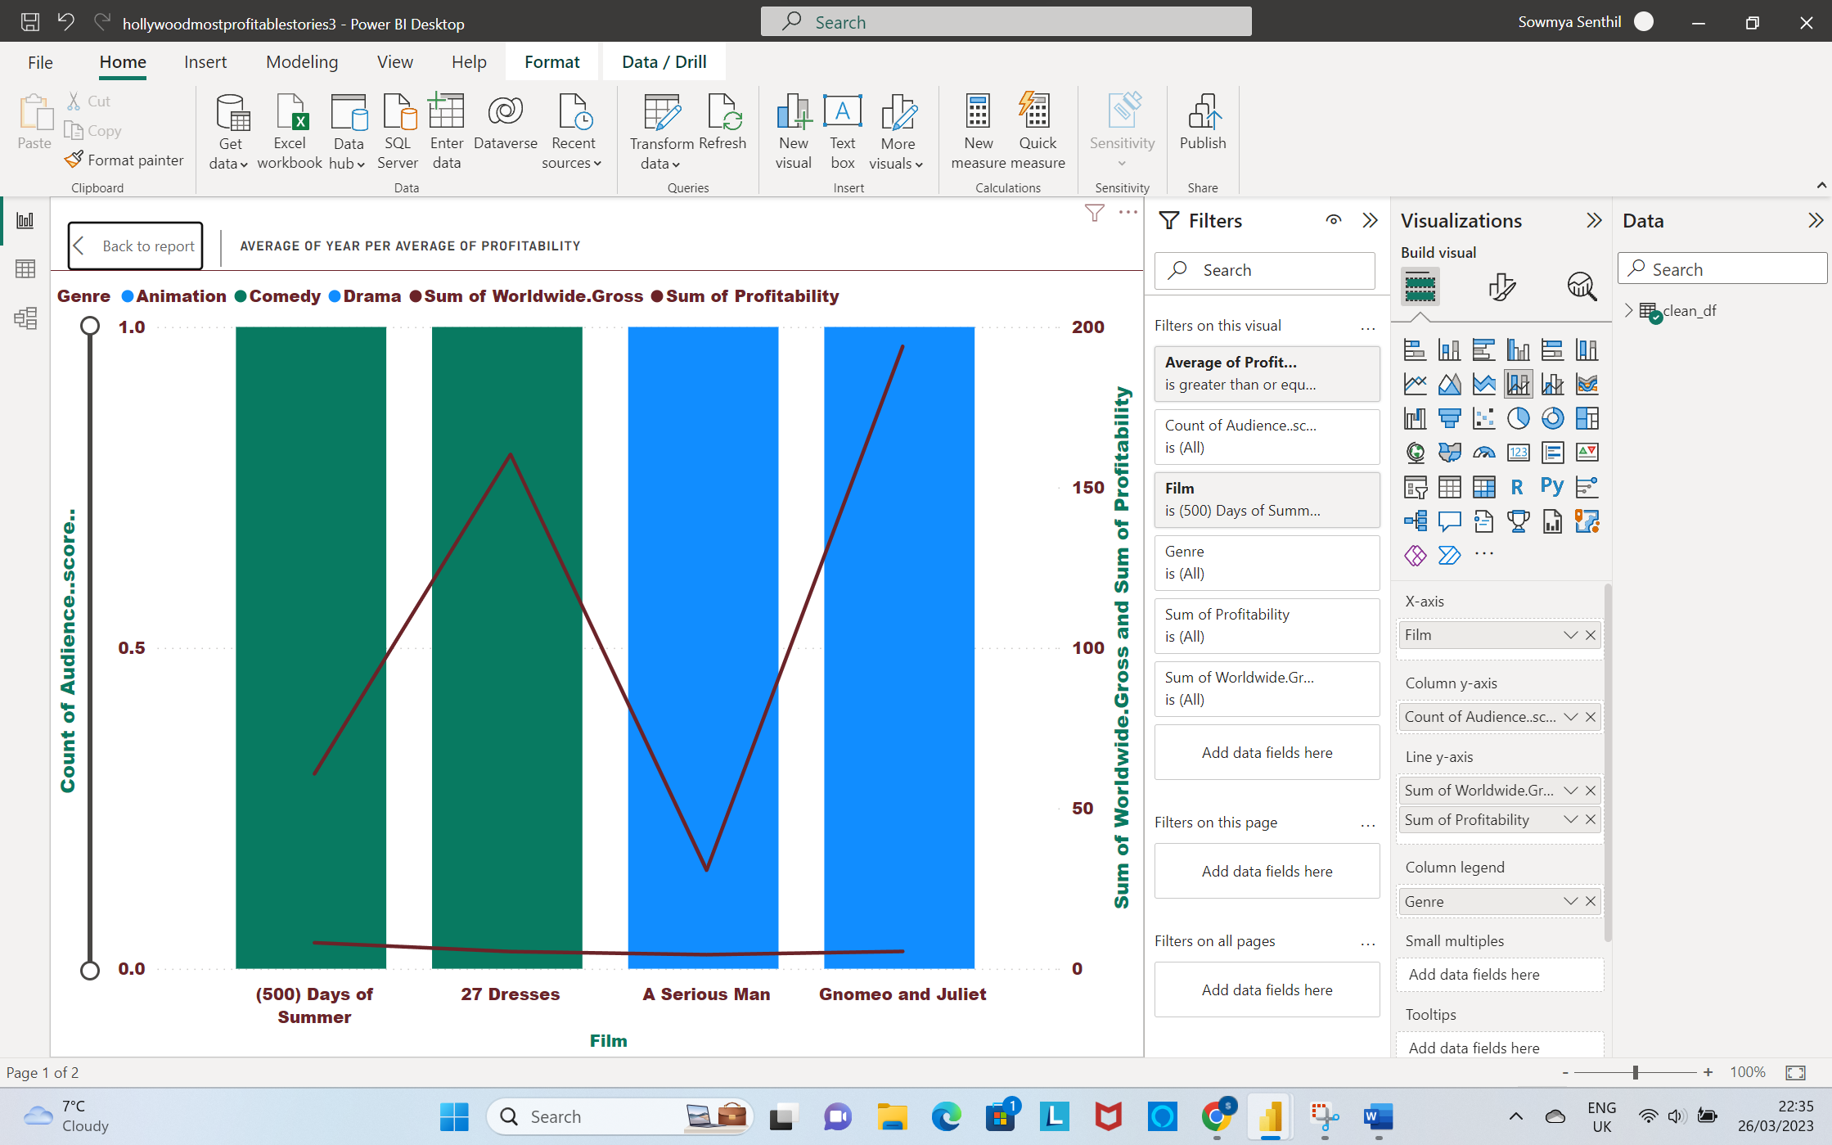

**Thank You**